MATLAB BASICS
Instructor: Prof. Shahrouk Ahmadi
TA: Kartik Bulusu

1. What are M-files
M-files are files that contain a collection of MATLAB commands or are used to define new MATLAB functions. For the purposes of this class, we will only need very simple M-files. However, you may find them useful for other parts of your homework as well. For example you may put a bunch of MATLAB commands into an M-file and then run all of those commands at the MATLAB prompt simply by typing the name of the M-file. You are also urged to create M-files while going through the handout.

How to make M-files in General

Make sure that the MATLAB command window is active.
Choose 'NEW M-file' from the 'File' menu. (This will bring up MATLAB's M-file editor.)
Type / Edit your file.
Choose 'Save' from the 'File' menu and then click on the 'DESKTOP' button, and then click on the Workspace icon.
In the 'SAVE document as:' box, type in the name you want to call the file. (There maybe a name in the box already, if it is ok leave it alone, otherwise change it.) Important: the name of your file should end in '.m', for example 'whatever.m' (without the quotes) is a fine name.
Finally click on the SAVE button to save the M-File.
In order to use this file please be sure to type 'start' in the MATLAB command window at the beginning of your session. This ensures that MATLAB will be able to find your M-files.

2. Matrices
The basic building block of MATLAB is the matrix. The fundamental data-type is the array. Special cases of this basic data-type are vectors, scalars, real and complex matrices.

An array is a list of numbers or expressions arranged in horizontal rows and vertical columns. When an array has one row or column, it is called a vector. An array with m rows and n columns is a called a matrix of size m × n. (Pratap, 1999)

Entering matrices into Matlab is the same as entering a vector, except each row of elements is separated by a semicolon (;) or a return:

B = [1 2 3 4;5 6 7 8;9 10 11 12]

B =
1 2 3 4
5 6 7 8
9 10 11 12

Transpose of a matrix

Matrices in Matlab can be manipulated in many ways. For one, you can find the transpose of a matrix using the apostrophe key:

C = B'

C =
1 5 9
2 6 10
3 7 11
4 8 12

Matrix Multiplication

Now you can multiply the two matrices B and C together. Remember that order matters when multiplying matrices.

D = B * C

D =
30 70 110
70 174 278
110 278 446

D = C * B

D =
107 122 137 152
122 140 158 176
137 158 179 200
152 176 200 224

Another option for matrix manipulation is that you can multiply the corresponding elements of two matrices using the .* operator (the matrices must be the same size to do this).

E = [1 2;3 4]
F = [2 3;4 5]

Term by term multiplication (.*)

G = E .* F

E =
1 2
3 4

F =
2 3
4 5

G =
2 6
12 20

Matrix Exponentiation

If you have a square matrix, like E, you can also multiply it by itself as many times as you like by raising it to a given power.

E^3

ans =
37 54
81 118

Term by term exponentiation (.ˆ )

If wanted to cube each element in the matrix, just use the element-by-element cubing.

E.^3

ans =
1 8
- 64

The inverse of a matrix:

X = inv(E)

X =
-2.0000 1.0000
1.5000 -0.5000

Matrix Division

P = E / F % This is similar to executing “P = E * inv(F)”

E =
1 2
3 4

F =
2 3
4 5

P =
1.5000 -0.5000
0.5000 0.5000

Term by term division (./)

Q = E ./ F

E =
1 2
3 4

F =
2 3
4 5

Q =
0.5000 0.6667
0.7500 0.8000

Matrix Equation:
Ax = b
X=A⁻¹ b
Matrix equation is used in solving linear simultaneous equations. For matrices of order 2 or 3, the calculation is simple and can be done on paper. However it is when one encounters matrices of larger orders that this computation becomes tedious and sometimes impossible without computer programs. A simple MATLAB program can be scripted to solve the matrix equation.
For example, consider the following set of equations that need to be solved for x, y and z.
x + y − z = 4
x − 2y + 3z = −6
2x + 3y + z = 7

In terms of the matrix equation the set of equations above become
$$\left[\begin{matrix}1 & 1 & −1 \\ 1 & −2 & 3 \\ 2 & 3 & 1\end{matrix}\right]\left[\begin{matrix}x \\ y \\ z\end{matrix}\right]=\left[\begin{matrix}4 \\ −6 \\ 7\end{matrix}\right]$$

Matlab program will have the following script.
A = [1 1 -1; 1 -2 3; 2 3 1];
B = [4; -6; 7];
X = inv(A) * B

The result should print out on the screen as follows:
X =
1.0000
2.0000
-1.0000

3. Handling Graphics
i) Line Plots
>> t = 0:pi/100:2*pi; % increments the value of t from 0 to 2*pi in steps of pi/100
>> y = sin(t);
>> plot(t,y)
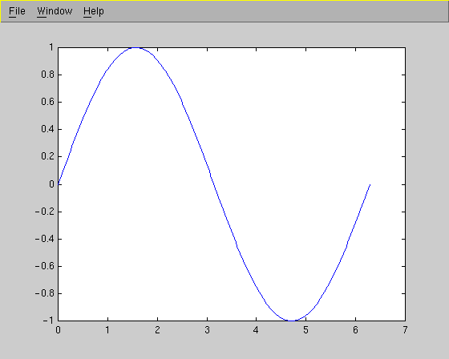

>> xlabel('t')
>> ylabel('sin(t)')
>> title('The plot of t vs sin(t)')

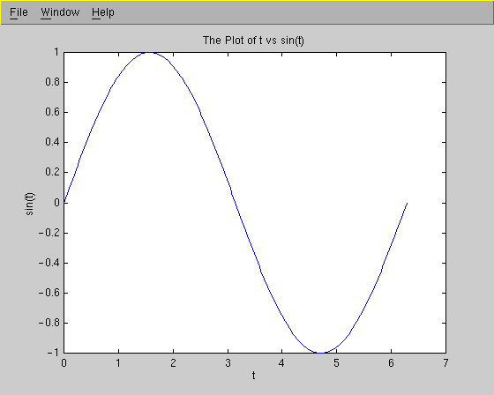

>> y2 = sin(t-0.25);
>> y3 = sin(t+0.25);
>> hold on; % <== to keep previously defined stuff
>> plot(t,y,t,y2,t,y3) % why not just plot only the 2nd and 3 curves?
>> legend('sin(t)','sin(t-0.25)','sin(t+0.25',1)

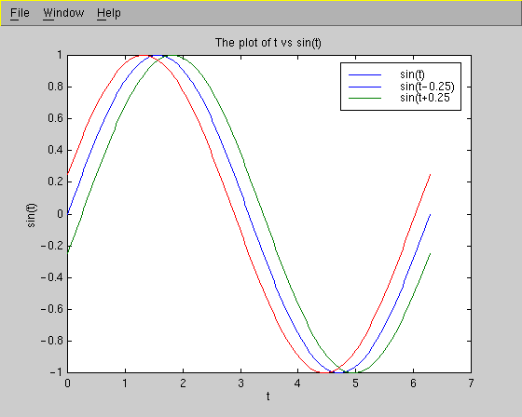

ii) Bar Graphs
>> x = magic(3)
x =
8 1 6
3 5 7
4 9 2
>> bar(x)
>> grid

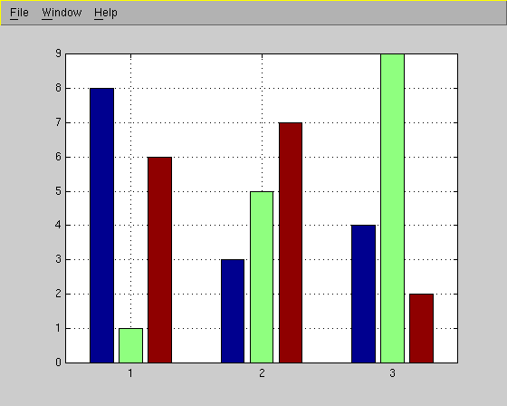

Example:
Suppose that you would like to plot the first 100 terms in the sequences
a_{n}= ncos(n)/(n²+1) and b_{n}= (.99)^{n}/3.
This can be accomplished with the following commands:
>> n=1:1:100;
>> a=n.*cos(n)./(n.^2+1);
>> b=(.99).^n/3;
>> plot(n,a,'bx',n,b,'r.'),shg
>> title('The Example: plots of a_n (the x''s) and b_n (the dots)')
The resulting graph is
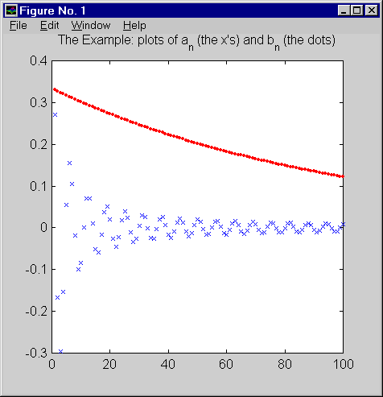

To learn more about the plot command, type the command:
>>help plot
Remark: The following commands would have worked as well to make the previous example.
>>n=1:1:100;
>>a=n.*cos(n)./(n.^2+1);
>> b=(.99).^n/3;
>> plot(n,a,'bx'),shg
>> hold on % (This keeps the previous graph from being erased.)
>> plot(n,b,'r.'),shg
>> title('The Example: plots of a_n (the x''s) and b_n (the dots)')

4. Polynomials

i) Entering a Polynomial
In Matlab, a polynomial is represented by a vector. To create a polynomial in Matlab, simply enter each coefficient of the polynomial into the vector in descending order. For instance, let's say you have the following polynomial:

To enter this into Matlab, just enter it as a vector in the following manner
>> x = [1 3 -15 -2 9]

x =
1 3 -15 -2 9

Matlab can interpret a vector of length n+1 as an nth order polynomial. Thus, if your polynomial is missing any coefficients, you must enter zeros in the appropriate place in the vector. For example,

would be represented in Matlab as:

>> y = [1 0 0 0 1]

ii) Evaluating a Polynomial

You can find the value of a polynomial using the polyval function. For example, to find the value of the above polynomial at s=2,

>> z = polyval([1 0 0 0 1],2)

z =
17

iii) Roots of a Polynomial

You can also extract the roots of a polynomial. This is useful when you have a high-order polynomial such as

Finding the roots would be as easy as entering the following command;

roots([1 3 -15 -2 9])

ans =
-5.5745
2.5836
-0.7951
0.7860

In-Class Exercise :
1. Solve
x + y + z = 6
x − y + z = 2
x + 2y − z = 2
for x, y and z using MATLAB

2. Solve
x + y − z = 1
8x + 3y − 6z = 1
−4x − y + 3z = 1
for x, y and z using MATLAB
3. Evaluate the following polynomial at x = 6 and calculate it’s roots.
$$x^{6}+3x^{5}−\text{100}x^{4}+\text{54}\text{.}\text{286}x^{3}+x^{2}+3x+6$$

References:
- http://scv.bu.edu/SCV/Tutorials/MATLAB/index.html
- http://math.ucsd.edu/courses/math21d/matlabhw/Basics/Matlab_basics.htm
- http://www.engin.umich.edu/group/ctm/basic/basic.html#matrix
- Pratap, R., Getting Started with MATLAB 5 - A Quick Introduction for Scientists and Engineers, Oxford University Press, 1999.

