Instructions for formatting your Matlab Project
And for uploading SEAS 001 Matlab Project to Blackboard System

- Choose one of the three matlab optimization assignments (power, projectile, or volume), from the class website: http://www.seas.gwu.edu/~seas001
- Make sure to use an “m-file” to do all of your work
- Make sure that all graph’s have titles, axis labels, and legends where appropriate
- Create one MS Word document that contains:
  - Matlab code
  - Output from matlab
  - Example:

Filename: Name your word file: SEAS001_GTA_Name_MatlabProject_LastName_FirstName.doc
Name: Thomas Farmer
Class: SEAS 001 Section 30
GTA: Thomas Farmer
Project: Example of project submission

Q1. Solve the system
x + y + z = 6
x − y + z = 2
x + 2y − z = 2
for x, y and z using MATLAB

Matlab Code:

A=[1 1 1 ; 1 -1 1; 1 2 -1]
b=[6 ; 2; 2]
x=inv(A)*b

Matlab Output:

x =
1
2
3

(include any plots in this section)

Interpretation:
Solution to system: x=1, y=2, z=3

See next page for instructions on how to submit this file on blackboard
To Upload your word file to blackboard perform the following steps:

- Navigate to: http://blackboard.gwu.edu
- Login using your GWU email username and password
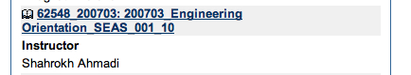
- Locate the SEAS 001 class, click on the link to open the class:

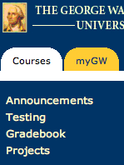
- From the left hand menu choose: Projects:

- Click on the “View/Complete Assignment: Matlab Design Project” link

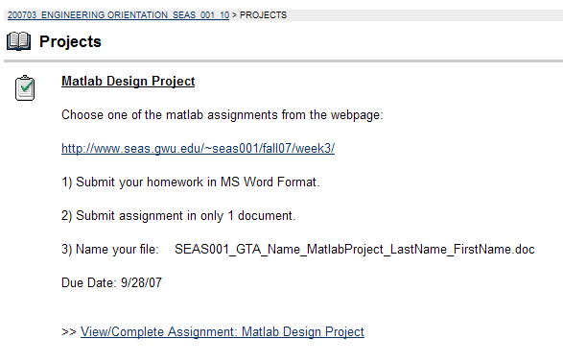
- Click on the link: “Choose File”
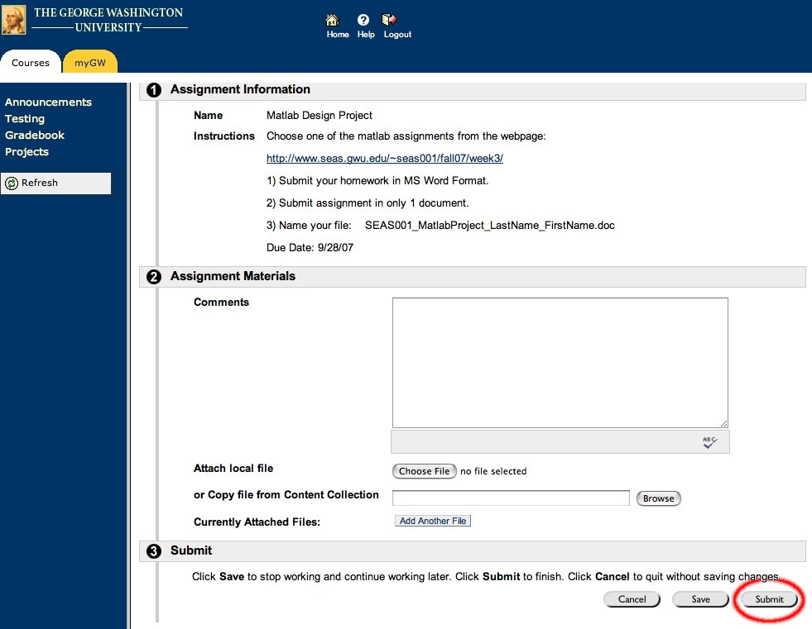

- Browse for your matlab file on your local machine, as you would for an email attachment
- Once you have chosen the file:
- THE MOST IMPORTANT STEP:
  - CLICK SUBMIT (DO NOT CLICK SAVE!!!)
`

