FOR WINDOWS USERS ONLY

This Guide is intended for Windows who have WSL installed on their computer and want to compile java code using WSL.

If you have WSL installed, please skip to Part 2 installing Java on WSL

Part 1: Installing WSL

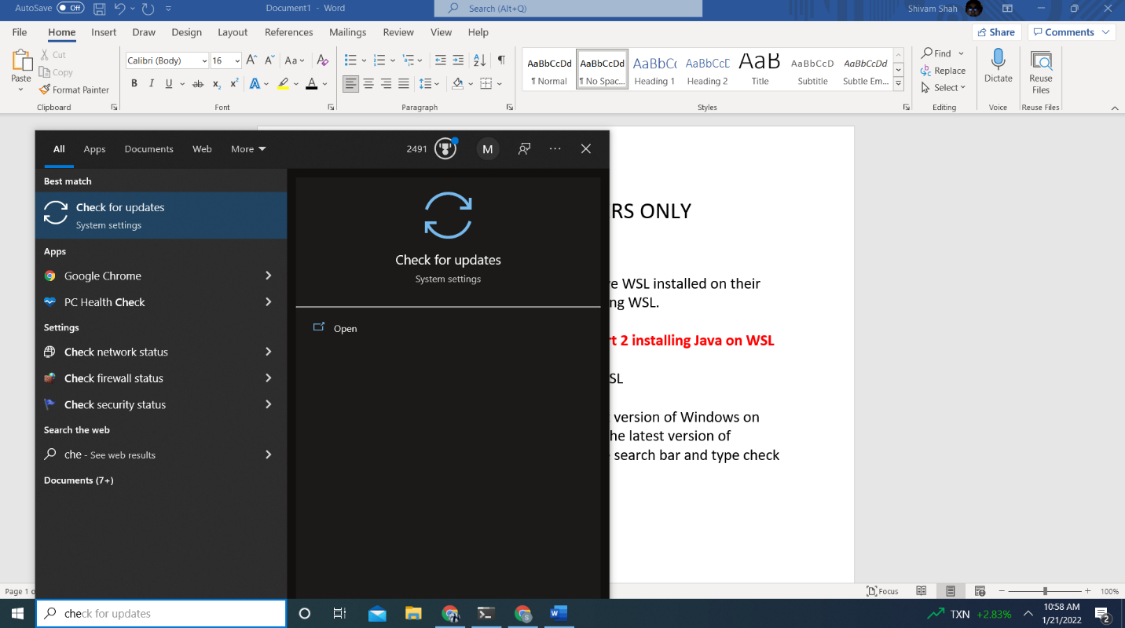
Step 1: Please make sure you have the latest version of Windows on your computer. To check to see if you have the latest version of Windows on your computer, please go to the search bar and type check for updates.

Step 2: Click on Check for updates and make sure you’re up to date.

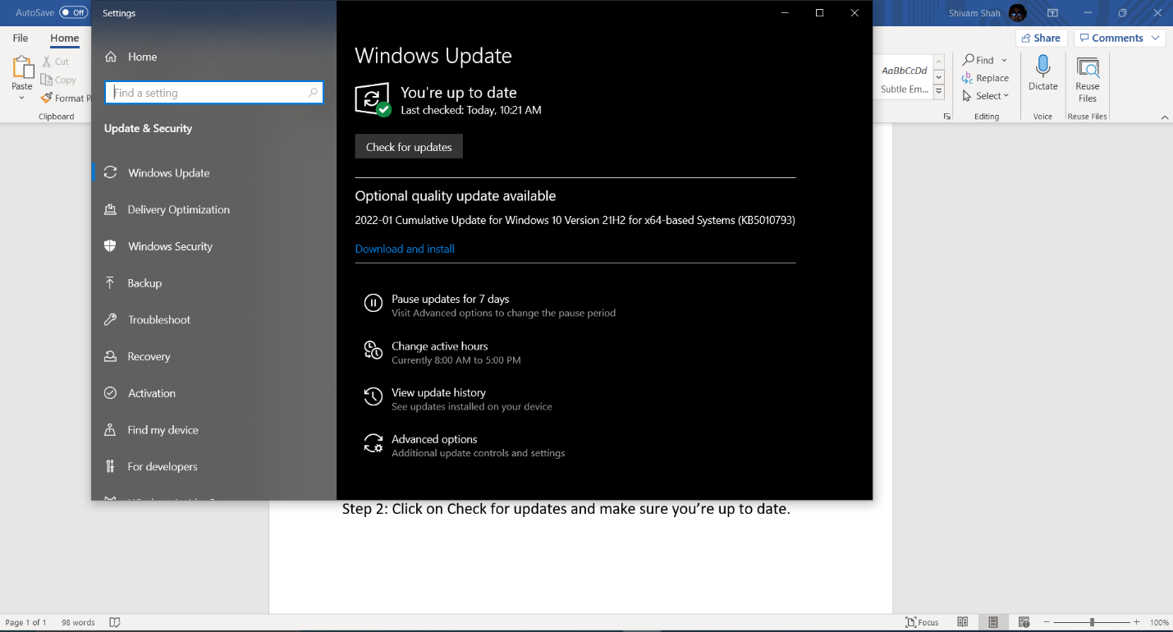
Step 3: After you’re done with all that follow the guide pasted down below I recommend using Install Ubuntu on Windows 10 via GUI

https://pureinfotech.com/install-ubuntu-windows-10/

You may get an error asking you to refine your search please copy and paste in this command

winget install -e --id Canonical.Ubuntu

This is the latest version.

Assuming you’ve followed the guide you should have installed WSL. YAY!!!

Part 2 Installing Java on WSL

Step 1: After you have installed WSL on your computer go to the search bar and type Ubuntu
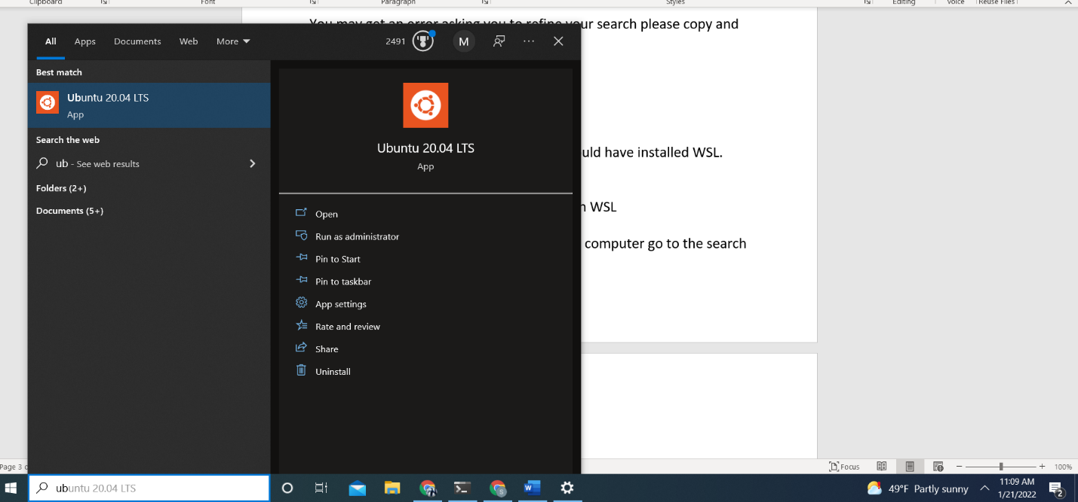
Step 2: After you click on ubuntu it will ask you to make a username and password. Create your username and password. DON’T FORGET YOUR PASSWORD!! IT IS SUPER IMPORTANT.
Step 3: After you’ve done that, please run the following commands on terminal
- sudo apt-get update –fix-missing
- sudo apt-get upgrade
NOTE: after you run the first command it may ask for a password. The password is the password you created earlier in the steps.

Step 4: After that is done run the following commands
- sudo apt-get install default-jdk
- sudo apt-get install openjdk-12-jdk-headless
- javac –version
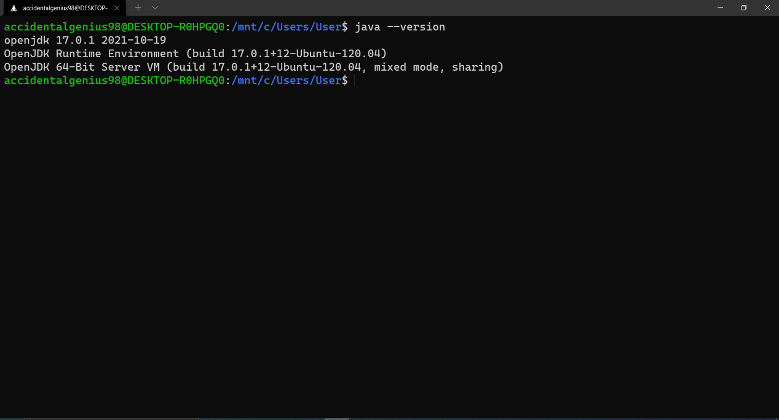
Assuming you’ve done all of that your version should be something along the lines of this.

Part 3 Combining Windows and Ubuntu Terminal (Easy Wayish)
NOTE: If you plan on doing this the easy way keep in mind that your default command line will now become Ubuntu Terminal. If you decide to do part 3 please skip part 3.5
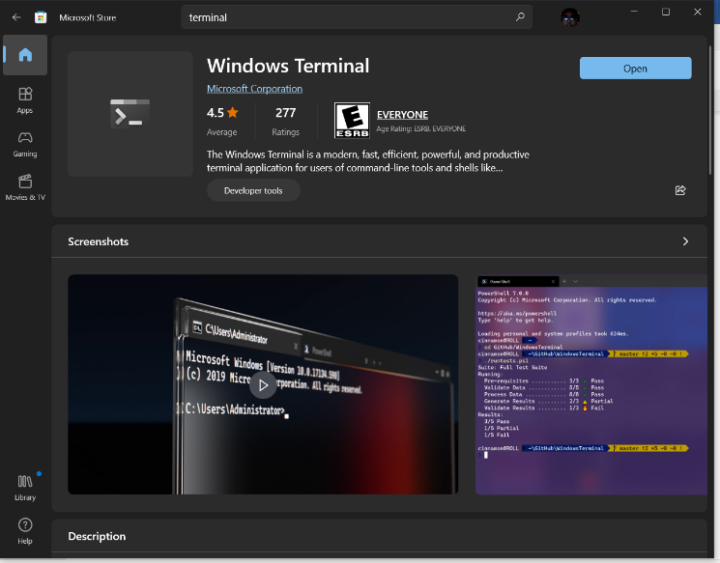
Step 1: Go to the Windows store and install Windows Terminal

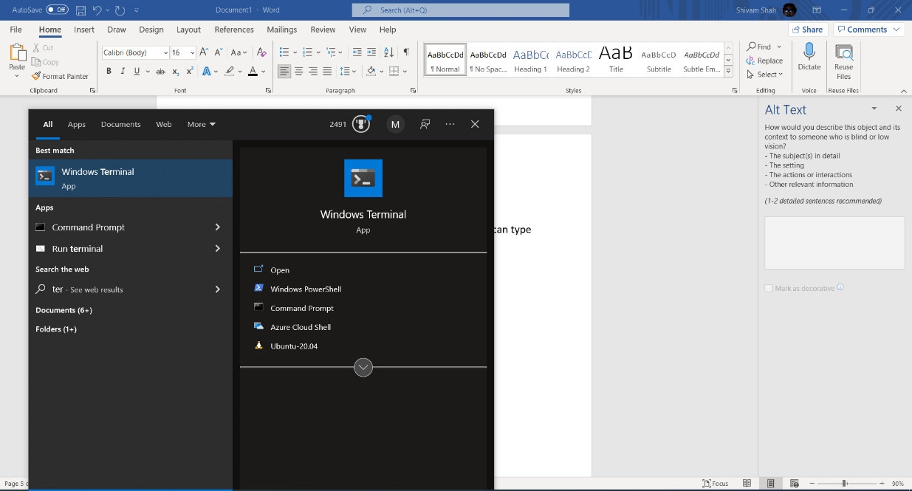
Step 2: Open terminal either thru the store or search bar you can type terminal

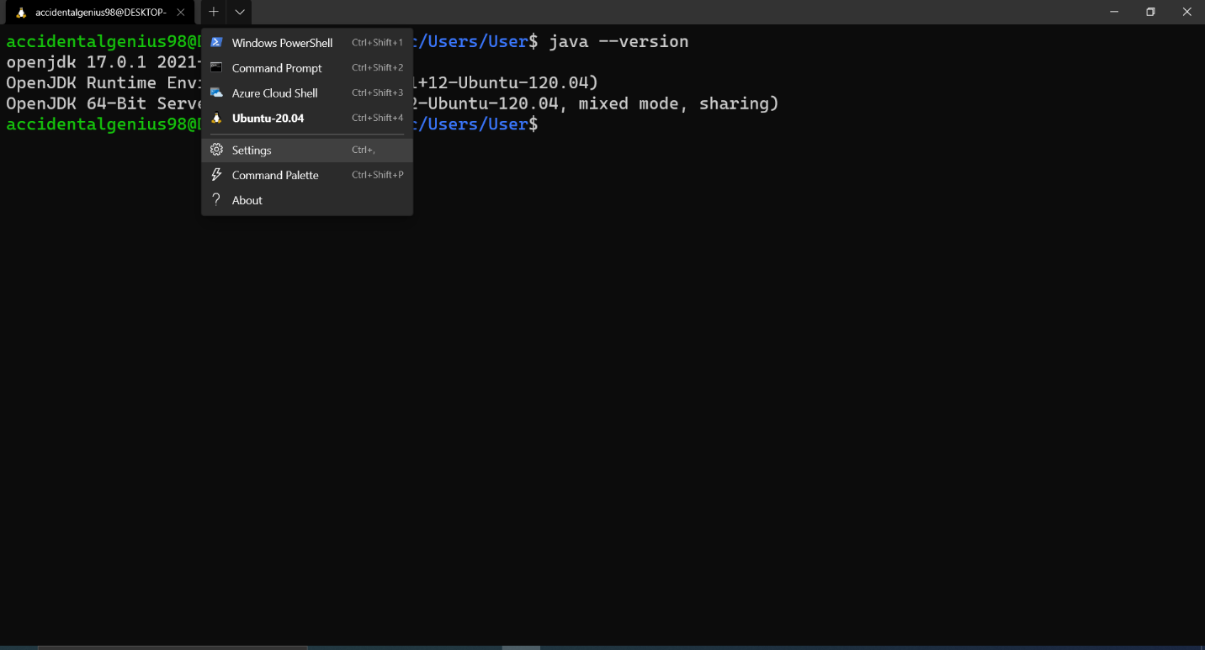
Step 3: From there click on the arrow on the top left and click settings

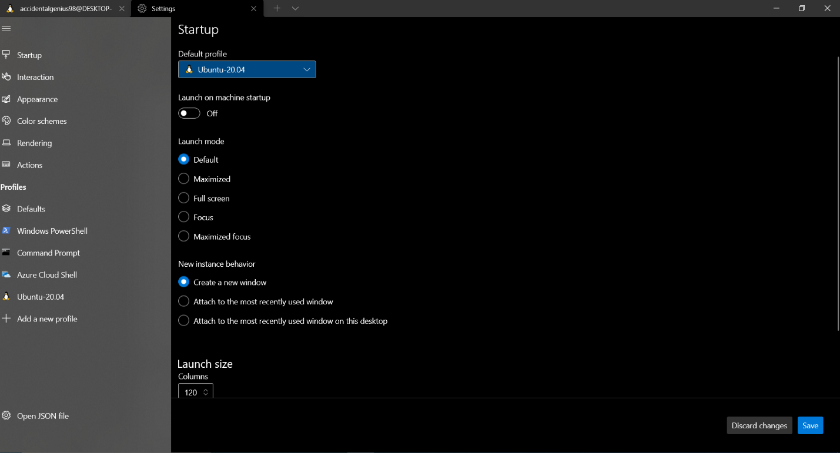
Step 4: From there click on Default Profile

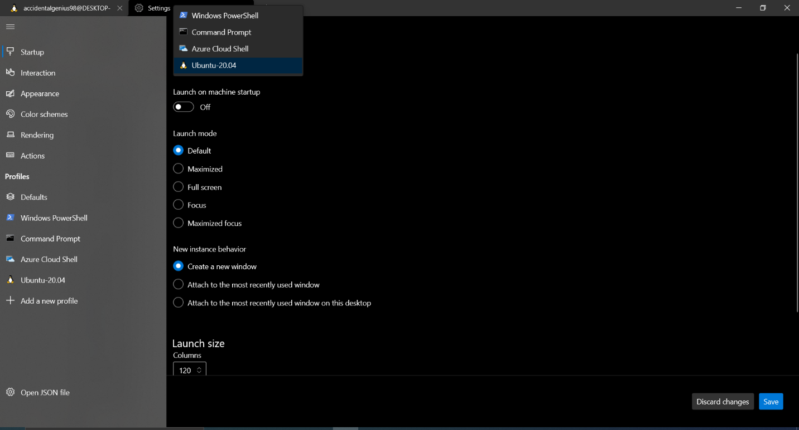
Step 5: Change Default Profile to Ubuntu 20.04 or whatever version your Ubuntu is

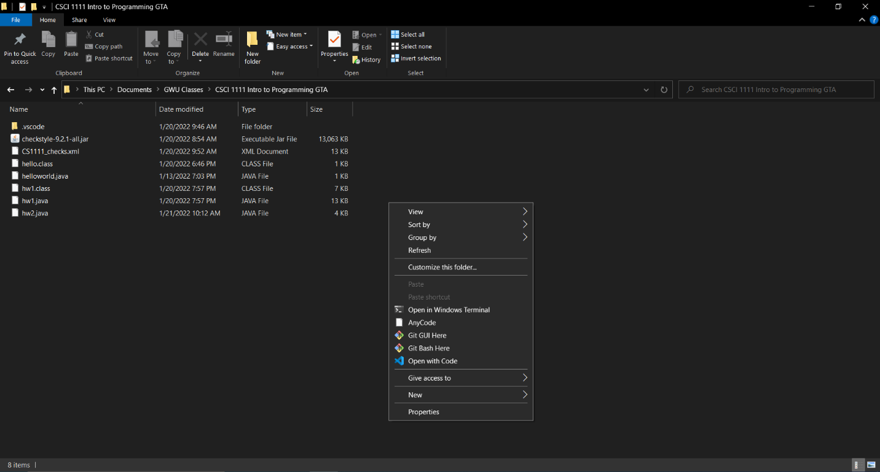
Step 6: You’re done now whenever you right click you can open any directory with windows terminal!!!

Purpose of this: So the idea is that the first time doing all of this is difficult however now whenever you need to run code you can go to the directory right click and use Open in Windows Terminal and run the code.

Part 3.5 Combining Windows and Ubuntu Terminal (Harder Wayish)
NOTE: IF YOU HAVE FOLLOWED PART 3 SKIP THIS!!
Step 1: open Ubuntu
Step 2 Type in the following commands:
- cd ..
- cd ..
If you did that you should be here
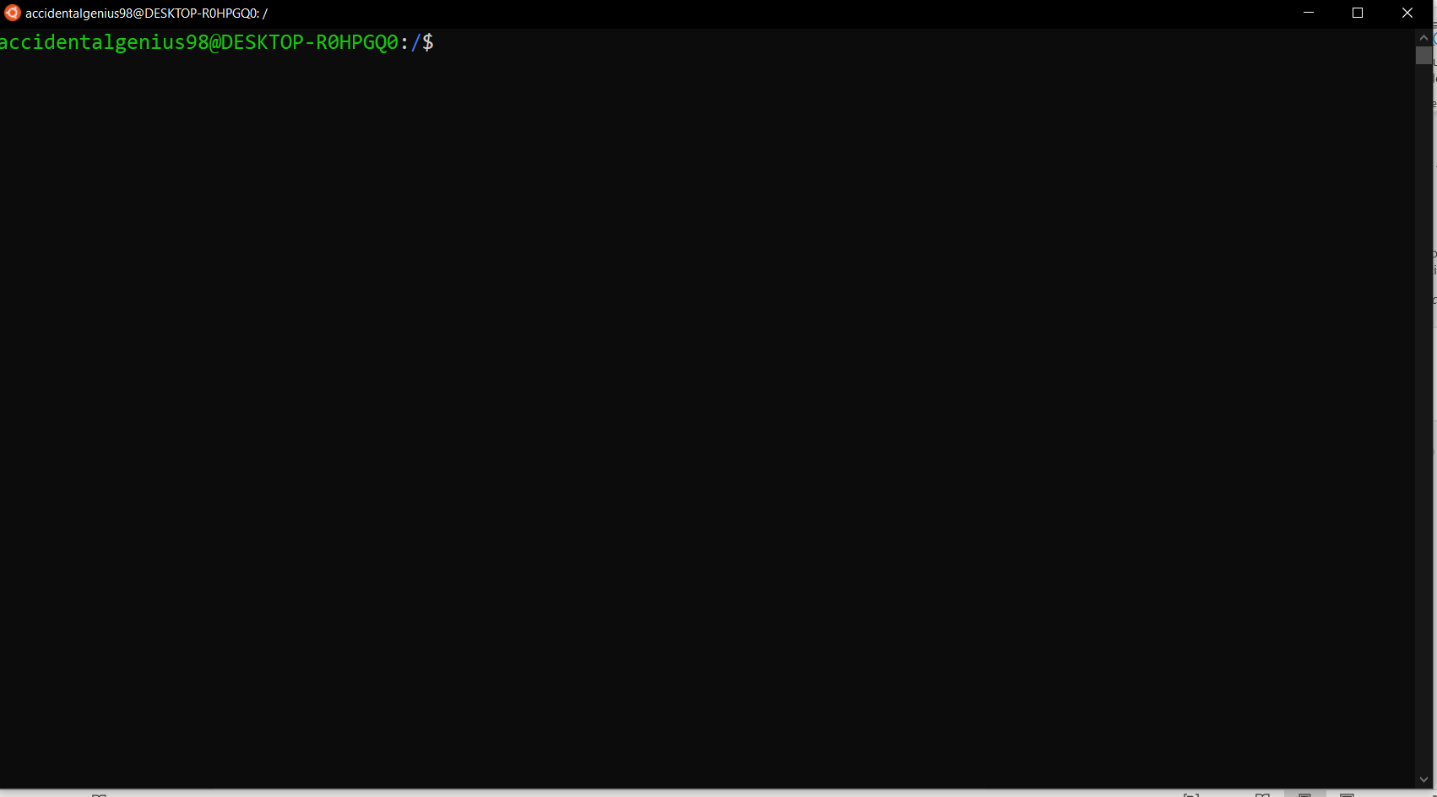

Step 3: type int the following commands
- ls
- cd mnt/
- cd c/
This is you accessing your C drive on Windows and you will see everything on your C drive from here so if you type la -al you should see your whole directory

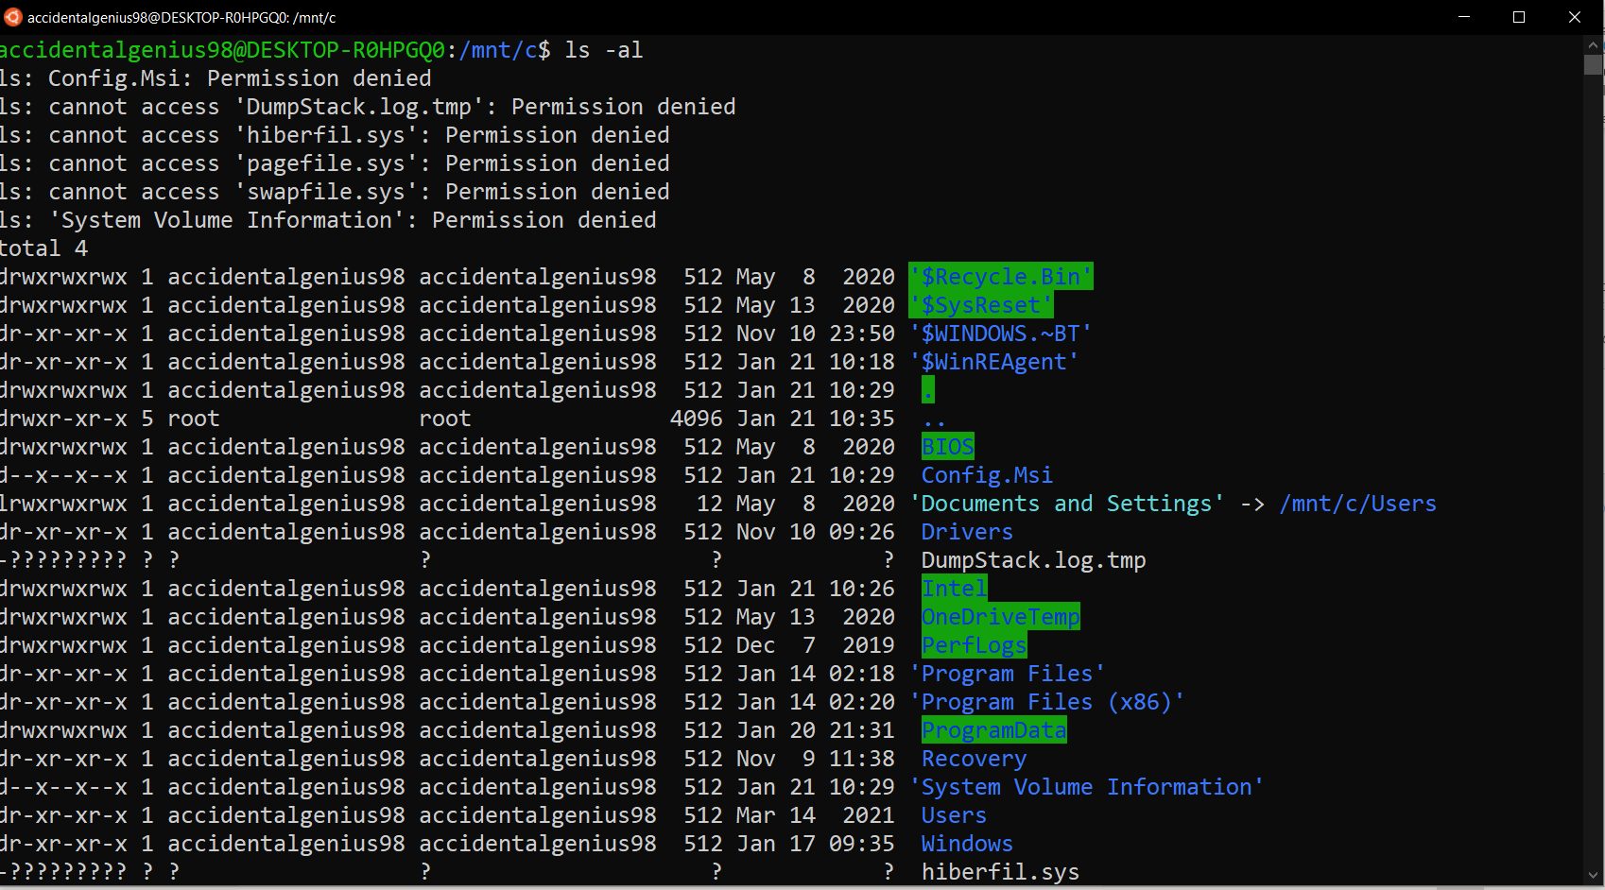
From here you can access all your files. The good thing about this is that you don’t have to install anything else the bad things however is you need to know how to navigate with linux commands so it will be difficult initially. I RECOMMEND PART 3.

PART 4 installing CHECKSTYLE and COMPILING CODE
Step 1: Download the following Files into the same directory. I recommend making a CSCI 1111 directory
- https://github.com/checkstyle/checkstyle/releases/download/checkstyle-9.2.1/checkstyle-9.2.1-all.jar
- https://www2.seas.gwu.edu/~kinga/CS1111_S22/labs/checkstyle.html
- https://www2.seas.gwu.edu/~kinga/CS1111_S22/HelloWorld.java

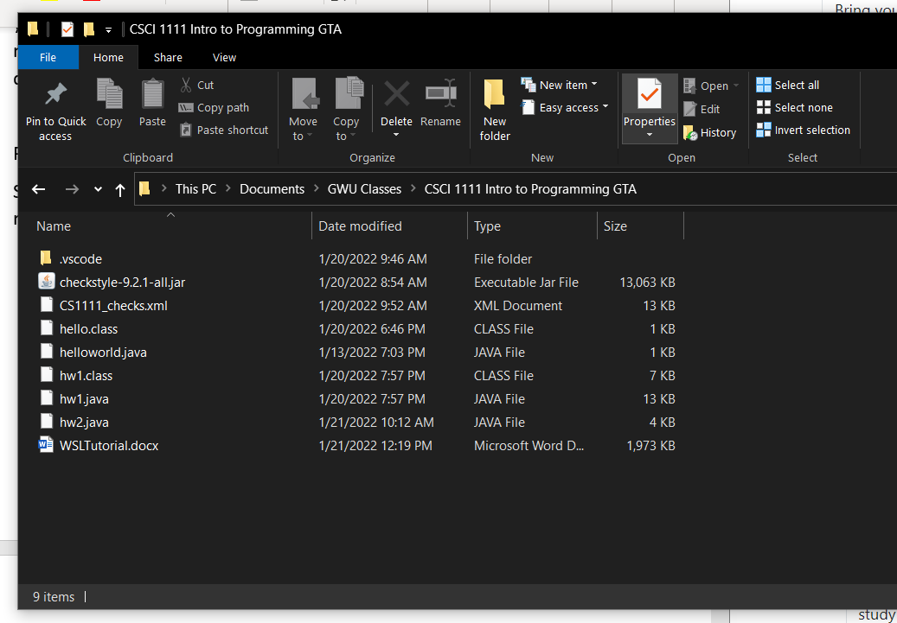
Step 2: Run the following command
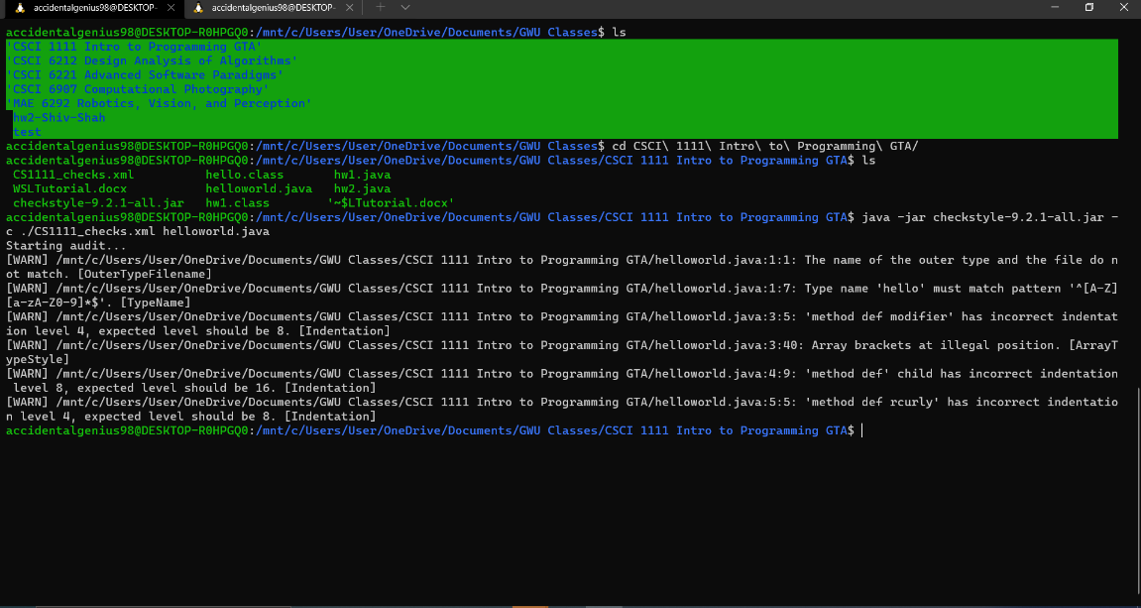
- java -jar checkstyle-9.2.1-all.jar -c ./CS1111_checks.xml HelloWorld.java
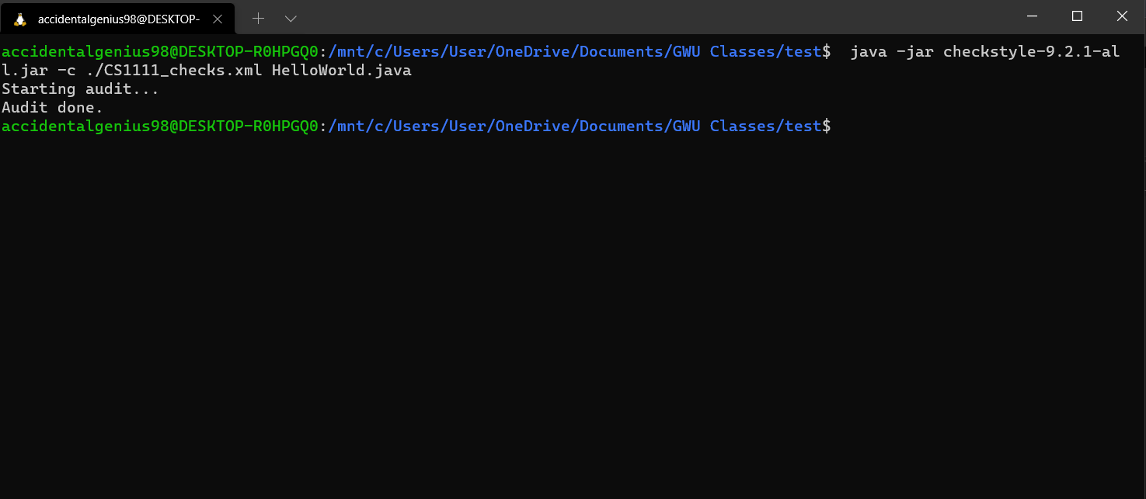
Step 3: Fix all your warnings and after that is done you should get something like this.

Step 4: Compile and Run your code
- To compile your code run the following command
  - javac HelloWorld.java
- After it compiles run the following command
  - java HelloWorld
That’s it you’re done!!!

For all the labs in the future please run CheckStyle and make sure that there are no warnings and use javac and java to compile and run your code!!
If you have any questions, please reach out to any Lab person.
Hope this was helpful and have a great Semester!!!

