The George Washington University
School of Engineering and Applied Science
Department of Electrical and Computer Engineering
ECE 20 – SPICE Tutorial 8

Loading New Parts into Spice

Background:

Whether you are using Orcad-Lite (the version of SPICE that comes with the Sedra Textbook) or Cadence SPICE (the version in the lab), you can load new parts into SPICE. What is needed to load a new part is a “SPICE Model” for the device. A SPICE model tells SPICE how the new part operates when voltages and currents are applied to the device. One can even create their own model for a device. Often manufacturers will supply a SPICE model for their device on their website; often it accompanies the datasheet on their website. This tutorial discusses how to load a manufacturer’s model into either version of SPICE. In this tutorial, we’ll use a BJT with part name: TIP31A as an example for how to load a new part into spice

Procedure:

A spice model (for Orcad or Cadence SPICE) for a new part is contained in two files:

- A .lib file
- A .olb file

These files may be obtained from the part manufacturer’s website (in some cases), or in some cases from the manufacturer of Orcad, Cadence’s, website:

https://www.cadence.com/products/orcad/Pages/downloads.aspx

For this tutorial, we have posted the necessary files on the course website.

- Download the SPICE model files: PWRBJT.OLB and PWRBJT.LIB from the ece20 lab website:

http://www.seas.gwu.edu/~ece20

Create a new directory on your computer entitled:

C:\Program Files\OrcadLite\downloaded_libraries

Store the two downloaded files in that directory
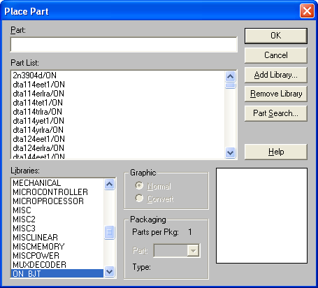
- Open Orcad/SPICE, start a new blank project
- From the menu choose: Place->Part
- Click on the “Add Library…” button
- Browse to the folder you downloaded the SPICE models to, click on the file: PWRBJT.OLB, press OK

- Now type in the new part name you wish to use, in this case: TIP31A
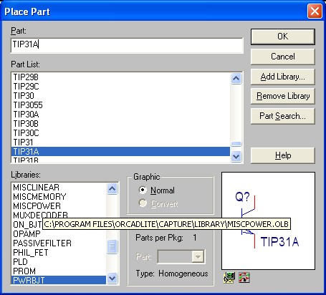
  - Notice the your new library is loaded and the part TIP31A can be found

- The procedure above really only loads the “symbol” for the part, when you attempt to simulate it won’t work unless we load the other file we’ve downloaded

- Let’s assume you’ve built a circuit using the TIP31A and now it is time to simulate:

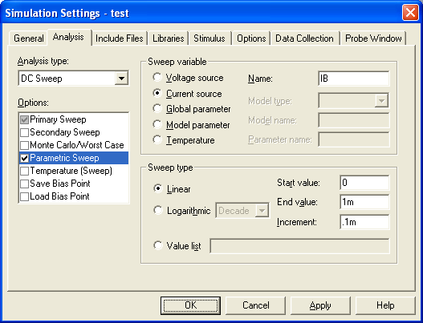
  - After you’ve setup your simulation, click on the “Libraries” tab of the Simulations Settings box

- Click on “Browse” button and locate the PWRBJT.LIB file you downloaded earlier

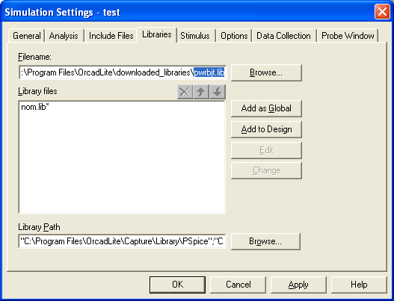
  - Afterwards, click on the “Add to Design” button to ensure the simulator can locate the SPICE model during simulation
  - Then press OK and run your simulation

- If you see an error that your part is “undefined,” you probably haven’t clicked on “Add to Design” as show in step 9.

WARNINGS:

You may find a library on the Internet that has your PART # within it. If you download and use this library, perform some simple IV simulations to ensure it actually matches your manufacturer’s specification sheet.

If the library doesn’t procedure similar IV-curves to your SPEC sheet, it may not be the right part, be very careful of this! It is always a good idea to perform a simple simulation and ensure it matches your SPEC sheet before relying on it.

