The George Washington University
School of Engineering and Applied Science
Department of Electrical and Computer Engineering
ECE 20 – SPICE Tutorial 4

Bias Point Analysis by Hand and In SPICE

Description:

When BJT’s are used in actual circuits, there is typically a single voltage supply. This is due to where the transistor will be used. For example, in a cellular phone there is just one battery, perhaps 3.3V, in a car a 12V battery, in an MP3 player 1.5V, etc. We would like to use two separate voltage sources to ‘bias’ our transistor, as shown in the example circuit in figure D.1, a 5V for the base, and a 15V for the collector & emitter. But due to the fact that we have only 1 voltage source, say it is 15V, we need to apply the proper voltage to base & the collector, from only 1 single voltage supply, as shown in figure D.2. This tutorial will show that figures D.1 and D.2 apply the same voltage to the base, collector, and emitter. And most importantly, all of the currents (IB, IC, & IE) will be identical for each circuit.

Figure D.1 – Circuit to ‘bias’ transistor Q1 using 2 V sources | Figure D.2 – Circuit to ‘bias’ transistor Q1 using 1 Vsource

The circuit in D.2 is sometimes called a “Beta Stabilizer” since the value for β is fixed, since IB & IC will be fixed at a particular value. The example used in this tutorial follows example 5.10, p 430 in the Sedra/Smith “Microelectronic Circuits” textbook, except that no steps are skipped.

Hand Calculations:

In the circuit in figure 1.1, we are typically asked to find the voltage and current at each node, specifically: VC, VB, VE, IC, IB, and IE.
IB
IC
IE
Given Information:
β = 100

Equations true for any BJT:

β = IC/IB (DC Current Gain)

IE=IB+IC (KCL)

Fig 1.1 – Typical Bias Circuit for a BJT

- We don’t know the voltage at VB, or the current IB, so we start by finding the Thevenin equivalent for VCC, RBB1, and RBB2:

- Recall that Thevenin’s theorem states that any combination of voltage sources, current sources and resistors with two terminals is electrically equivalent to a single voltage source and a single series resistor. We can see from figure 1.1 that RBB1 and RBB2 have 15Volts across them. So we redraw the first part of the circuit as follows:

VTH
+
-
- This is just a simple voltage divider, where VTH equals 5V:

$$\text{VTH}=\text{VCC}\left(\frac{\text{RBB}2}{\text{RBB}1+\text{RBB}2}\right)=\text{15}V\left(\frac{\text{50}K}{\text{100}K+\text{50}K}\right)=5V$$

- From Thevenin’s theorem we know that to find the Thevenin resistance we short the voltage source, and find the equivalent resistance (RTH):

RTH

- RTH is simply two resistors in parallel, or 33.3KΩ:

$\text{RTH}=\left(\frac{\text{RBB}1\text{xRBB}2}{\text{RBB}1+\text{RBB}2}\right)=\left(\frac{(\text{100}K)(\text{50}K)}{\text{100}K+\text{50}K}\right)=\text{33}\text{.}3KΩ$

- The next step is to put this all together and replace RBB1 and RBB2 with the Thevenin equivalent:
-
IB
IC
IE
L1
VBE
+
Figure 1.2

- The next step is to use the Thevenin equivalent circuit to determine IB, IE, and IC:

- In figure 1.2, we can use KVL on Loop L1 to determine IB, and IE:

$$\text{VTH}=\left(\text{IB}∗\text{RTH}\right)+\text{VBE}+\left(\text{IE}∗\text{RE}\right)$$

- ASSUMPTION YOU MUST MAKE: We assume that the BJT is in its “active” region, essentially meaning that the device is “ON.” Because the Base-Emitter junction is a essentially a diode, when it is turned “ON,” it has roughly a .7V drop across it. In Lab 4, you determined the actual value for VBE, looking back you will see it was approximately: .6V-.7V, so this is a valid assumption. This assumption makes it so VBE=.7V in the equation we derived from KVL:
$\begin{aligned}\text{VTH}=\left(\text{IB}∗\text{RTH}\right)+\text{VBE}+\left(\text{IE}∗\text{RE}\right) \\ 5V=\left(\text{IB}∗\text{33}\text{.}3K\right)+\text{.}7V+\left(\text{IE}∗3K\right)\end{aligned}$ Equation 1.1

- We don’t yet know IB, or IE. But we remember that for a BJT, KCL states the currents going into the BJT must equal the current coming out of the BJT:

IB + IC = IE Equation 1.2

- And we remember that DC Current Gain for a BJT is called Beta β:

β=IC / IB Equation 1.3

- Using these two facts, we can plug one equation into the other and put emitter current (IE) in terms of base current (IB):

IE=(1+β)*IB Equation 1.4

- Now we can substitute equation 1.4 into equation 1.1:

$5V=\left(\text{IB}∗\text{33}\text{.}3K\right)+\text{.}7V+\left(\left(1+β\right)\text{IB}∗3K\right)$ Equation 1.5

- Since β is given to be 100 for this BJT (in the active region of operation), we can solve for IB in equation 1.5 above:
$$\begin{aligned}5V=\left(\text{IB}∗\text{33}\text{.}3K\right)+\text{.}7V+\left(\left(1+β\right)\text{IB}∗3K\right) \\ 5V=\left(\text{IB}∗\text{33}\text{.}3K\right)+\text{.}7V+\left(\left(\text{101}\right)\text{IB}∗3K\right) \\ 5V−\text{.}7V=\left(\text{IB}∗\text{33}\text{.}3K\right)+\left(\text{IB}∗\text{30}\text{.}3K\right) \\ \text{IB}=\text{12}\text{.}7\text{uA}\end{aligned}$$

- From equation 1.4, we find that IE = 1.29mA
- From equation 1.2, we find that IC = 1.27mA

- Using the current’s found above (IB, IE, IC) and the size of the resistor’s RTH, RE, RC, the last step is to use Ohm’s law to determine VC, VB, and VE:

- From figure 1.2, find VB using Ohm’s Law:
V=IR → (VTH – VB) = (IB)(RTH) → VB = VTH – (IB)(RB) ≈ 4.6V

- Find VC: (Ohm’s Law)
V=IR → (VCC – VC) = (IC)(RC) → VC = VCC – (IC)(RC) ≈ 8.7V

- Find VE: (Ohm’s Law)
V=IR → (VE - GND) = (IE)(RE) → VE – 0 = (IE)(RE) ≈ 3.9V

From VC, VB, & VE, we can find VCE, VBE, & VCB, and we can easily see that VBE = .7V, which matches our assumption that we made earlier.

Performing a Bias Point Analysis in SPICE:

To verify that our hand calculations are correct, we perform what is called a “bias point” analysis in SPICE. This will allow us to view the node voltages and currents in our Beta Stabilizing network.

- Build the original circuit from Figure 1.1 in SPICE:
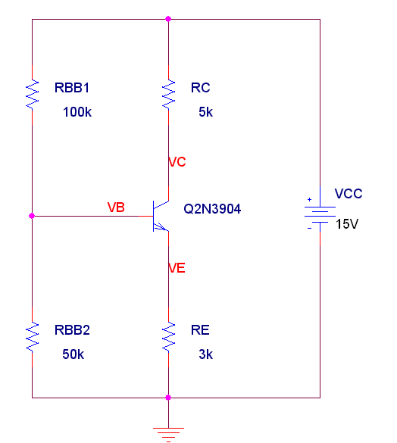
- Setup a new simulation profile in spice
  - Set the analysis type to “Bias Point”

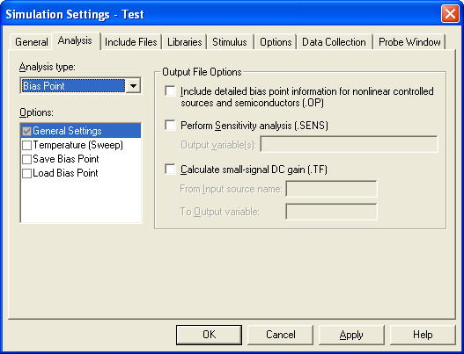

  - Run the simulation

- To see the node voltages, press the 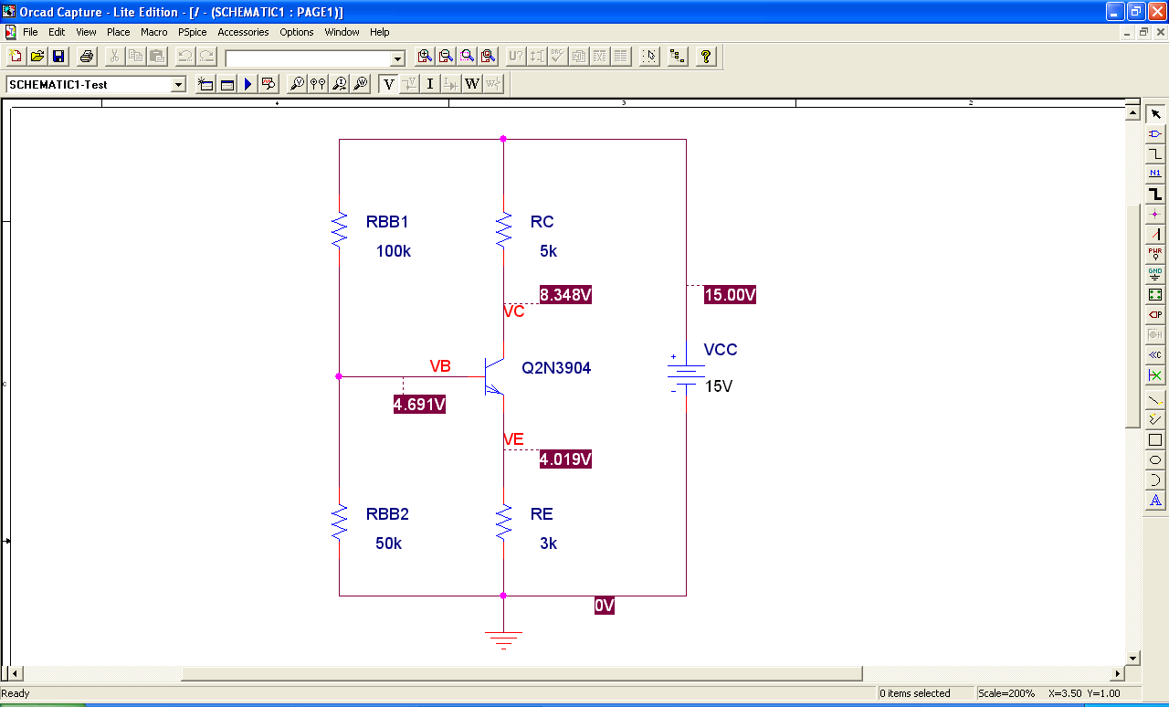 button on the top row of icons

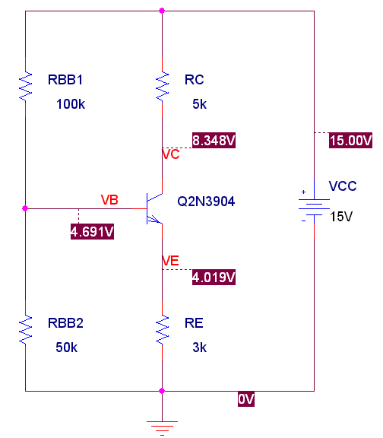
Notice, you can drag the node voltages away from the nodes & spice will add the dotted line

- To see the currents through the branches, press the 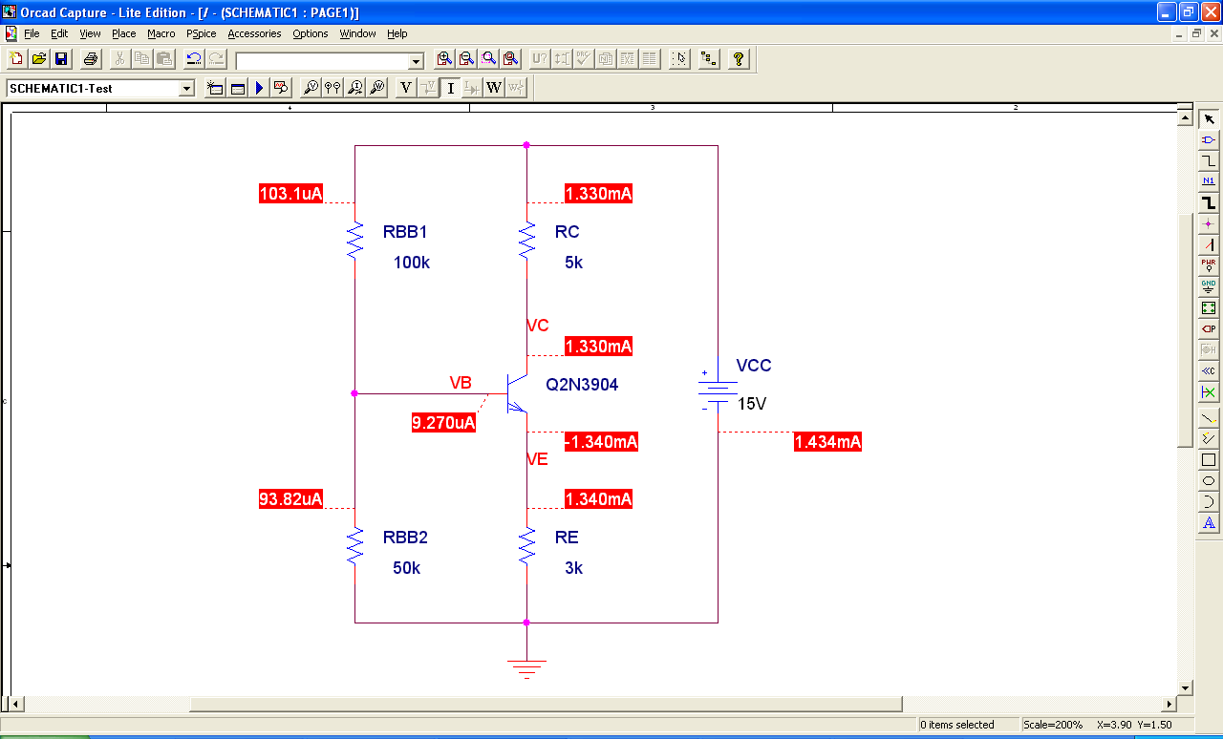 button on the top row of icons

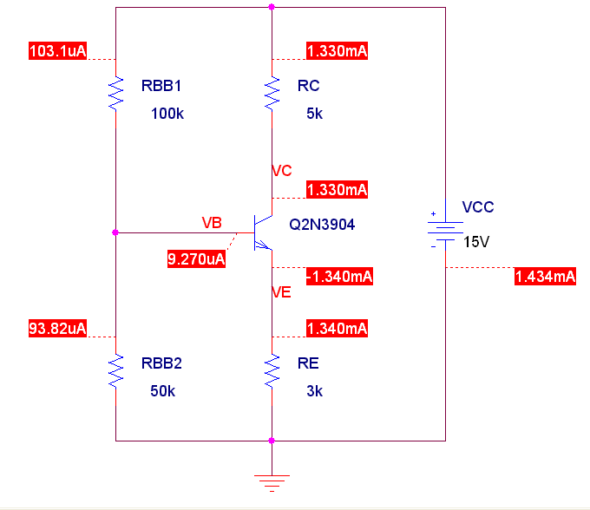
Notice that our currents and voltage DO NOT match our hand calculations! This is because the Q2N3904 has a β equal to about 180 for the values of IC and IB for this circuit’s configuration. The β used in the Sedra example was only 100. In our labs we will only use the Q2N3904, so in our hand calculations for the Q2N3904, we will use β=180, and it then match our spice simulations.

