The George Washington University
School of Engineering and Applied Science
Department of Electrical and Computer Engineering
ECE 20 – SPICE Tutorial 3

Parametric Sweep Simulation of a BJT

Description:

In this tutorial we discuss how to generate a typical IV-curve for a Bipolar Junction Transistor (BJT) in SPICE. To do this a DC Sweep simulation will be combined with a parametric simulation.

Background:

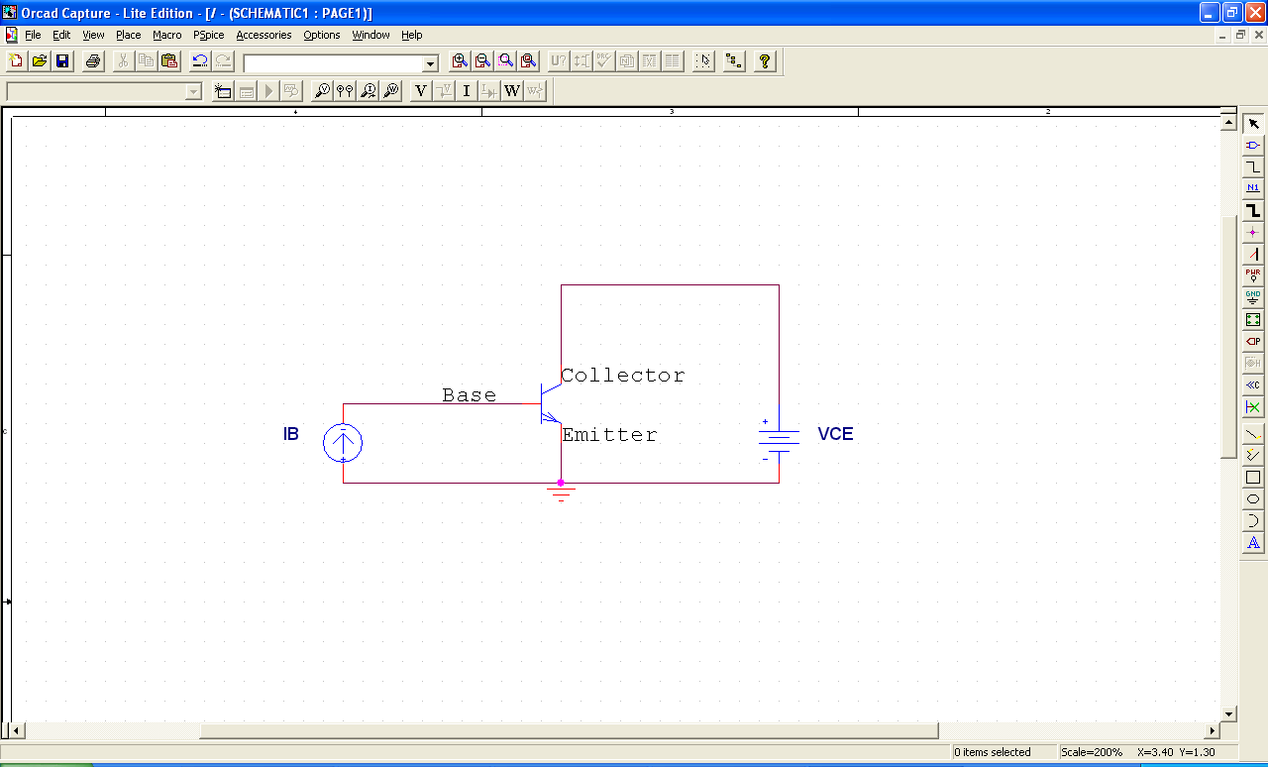  I_{C} – Collector Current | 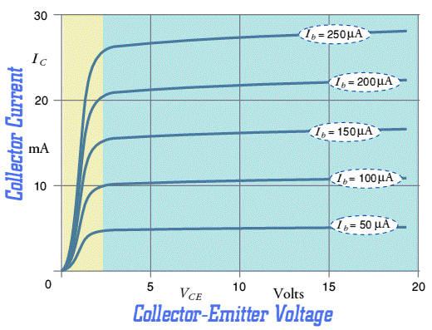
Fig 1: BJT Test Circuit | Fig 2: BJT IV-Curve [1]

A Bipolar Junction Transistor (BJT) is a 3 terminal non-linear device. Current applied to the base of the transistor (I_{B}) controls the amount of current that will flow from the Collector to the Emitter (I_{C}). In theory this is a “Current Controlled Current Source” (CCCS). I_{B} is the “control,” and the Collector-Emitter terminals act like those of a “current source” where the current is I_{C}.

In order to “turn on” the BJT device, we follow a two step process: 1) Apply voltage across the Collector-Emitter terminals (V_{CE}). 2) Apply current to the base terminal (I_{B}). Then current (I_{C}) will flow from the collector to the emitter, behaving as a current source.

Two “characterize” the full range of operation of the device, we vary both V_{CE} and I_{B} to see the variation in I_{C}. The test circuit used to characterize a BJT device is shown in Figure 1 above. The typical IV-Curve that this test circuit will produce is shown in figure 2 above. This tutorial will explain how to produce the IV-Curve in figure 2 using SPICE.

Plotting a single IV-Curve for the BJT:

- Build the following schematic in SPICE:

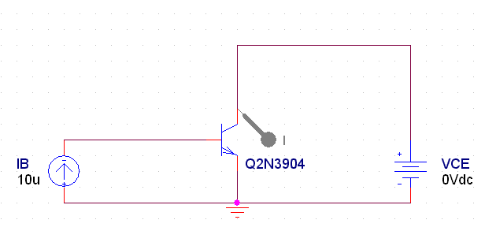
You will need the following parts:

IDC / SOURCE
VDC / SOURCE
GND (change name to 0)
Q2N3904 / EVAL
A Current Probe

- By default, the current source (IDC) and voltage source (VDC) will be named I1 and V1 respectively, rename them to IB and VCE as you see in the schematic above
- Make certain that the current source (IB) is upwards, ensuring that current will go ‘into’ the base of the transistor
- Set VCE=0V and IB=10uA

- With IB pushing 10uA into the base of the transistor, we will now sweep VCE from 0 to 10V, and observe its effect on I_{C}
- Create a new simulation profile
- Set the “Analysis Type” to be a DC Sweep
- Set the “Sweep Variable” to be a Voltage Source, and place the name of the voltage source you wish to sweep in the “Name” fill-in
- Set the start value for VCE to be 0V and the end value to be 10V
- Set VCE to be swept in .1V increments

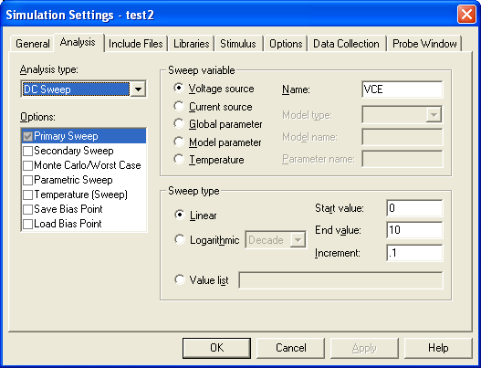

- Run the simulation, the following graph should result:

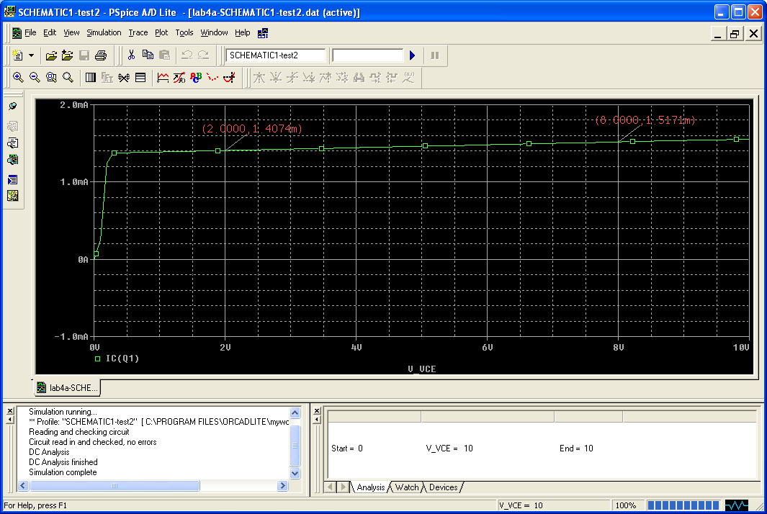

- This is a single IV-curve for a BJT
- Notice that the X-axis is the ‘swept variable’ (VCE)
- The Y-variable is IC – the current flowing into the collector of the transistor
- We remember from the schematic that IB is fixed at 10uA

From the markers on the graph we can interpret the following:
- When I_{B}=10uA and V_{CE}=2V, the collector current IC=1.407mA
- When I_{B}=10uA and V_{CE}=8V, the collector current IC=1.517mA

We now wish to perform a simulation where IB is not at a fixed value.
Plotting a family of IV-Curves for the BJT:

In the simulation above, IB was fixed at 10uA while VCE was swept. But we’d like to see how the BJT behaves if both VCE was swept and IB was changed to different values. This is known as a DC-Sweep combined with a Parametric Sweep, often called a “parametric simulation.” In our case IB is the ‘parameter’ we wish to vary while VCE is swept.

- Change the schematic built in the first portion of this tutorial to match the following schematic:

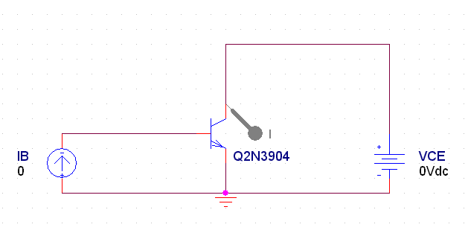
  - The only difference is that now IB is set to 0A

- Edit the simulation profile from the previous simulation as follows:

  - Keep the same settings for the DC-Sweep of VCE:

  - Now click on the “Parametric Sweep” check box

- For the Parametric Sweep settings, we want to vary IB from 0 to 50uA in steps of 10uA
- Set the sweep variable to be a ‘current source’
- Set the sweep variable’s name to be ‘IB’
- Set the start value for IB=0A and the end value to be 50uA
- Set the increment for IB to be 10uA

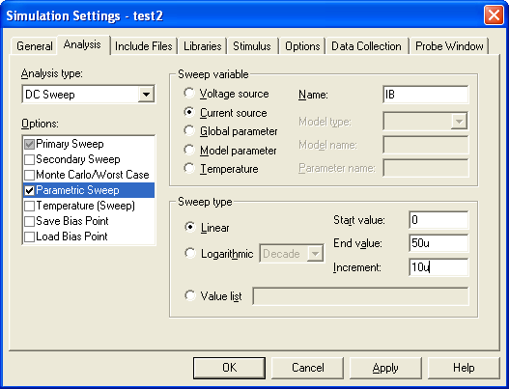

4) Run the simulation, the following graph will appear:

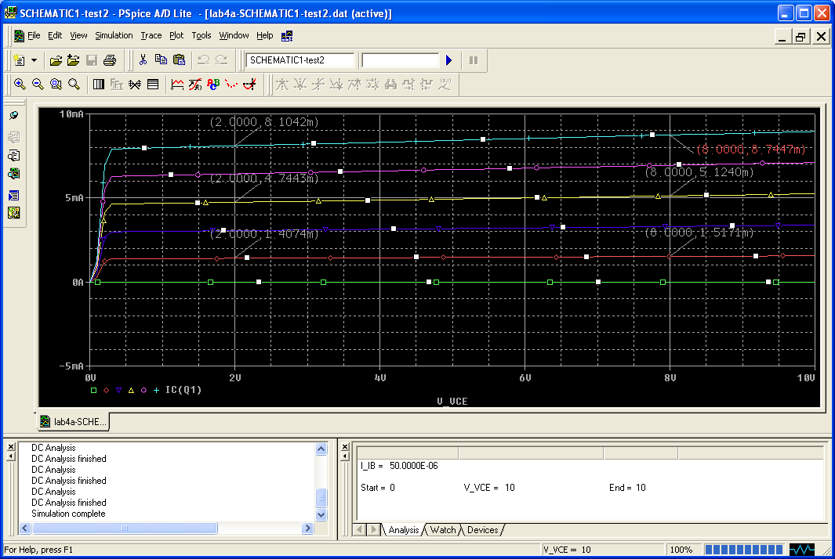
IB= 50uA
IB= 40uA
IB= 30uA
IB= 20uA
IB= 10uA
IB= 0A
- This is called a ’family’ of IV-Curves for the BJT
- The X-axis is still the DC Swept Variable (VCE)
- The Y-variable is still IC – the current flowing into the collector
- But now there is 1 IV-Curve for each value of IB that we specified: 0uA, 10uA, 20uA, 30uA, 40uA, and 50uA.
From the markers on the graph (on the RED curve) we can interpret the following:
- When I_{B}=10uA and V_{CE}=2V, the collector current IC=1.407mA
- When I_{B}=10uA and V_{CE}=8V, the collector current IC=1.517mA
(Notice that this is exactly the same as before!)

From the markers on the graph (on the Top BLUE curve) we can interpret the following:
- When I_{B}=50uA and V_{CE}=2V, the collector current IC=8.1042mA
- When I_{B}=50uA and V_{CE}=8V, the collector current IC=8.744mA
(Notice that this is exactly the same as before!)

We could use markers on each curve to find the value of IC at varying values of VCE.

What is incredibly important to take away from the second graph is the effect of IB on the transistor. Notice that IC (the collector current) is small (~1.5mA) when IB is small (10uA) for the given values of VCE. But when we increase IB to 50uA, IC is much, much higher (~8.5mA) for the same values of VCE! In effect IB has ‘controlled’ the value of IC, showing how this device behaves as a “current controlled current source.” It can be confusing, but if you look at the graph and ask questions in lab, this will be clearer.

References:

[1] University of Saint Andrews, "Curves Characteristic," The Physics and Astronomy Website, Date Unknown.
<http://www.st-andrews.ac.uk/~www_pa/Scots_Guide/info/comp/active/BiPolar/bpcur.html>

