The George Washington University
School of Engineering and Applied Science
Department of Electrical and Computer Engineering
ECE 20 – SPICE Tutorial 2

Simulating Transformers in SPICE

Description:

In this tutorial we discuss how to simulate two common types of transformers in SPICE.

Part I: Simulating a step down transformer

Background:
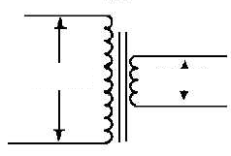
115 Vrms
9 Vrms
Primary coil
Secondary coil
Basic Transformer Equation:

Voltage to Turns to Inductance Ratio:

$$\frac{V_{P}}{V_{S}}=\frac{N_{P}}{N_{S}}=\sqrt{\frac{L_{P}}{L_{S}}}$$

P=Primary Coil S=Secondary Coil
V=Voltage, N=# of turns, L=inductance
Fig 1: Step down transformer

In ECE 11, you used a ‘function generator’ to generate sine waves for various experiments when you required a voltage with alternating current (AC). In an actual circuit (say inside of the power supply for a laptop computer), if we want an AC voltage, we use a transformer. In the United States, power companies provide an AC voltage of about 115V_{RMS} at the exact frequency of 60Hz. Most circuits can’t handle 115V_{RMS}, so we use a ‘step down’ transformer to ‘transform’ the voltage from 115V_{RMS} to a lower voltage, in this case about 9V_{RMS}.

Figure 1 shows the circuit schematic for a basic step down transformer. On the left terminals it can take as input a 115 V_{RMS} sinusoid. It will then ‘step down’ the voltage to a 9 V_{RMS} sinusoid. It is simple to see that this transformer has a step down voltage ratio of (115:9) or 12.77:1. The ratio for a transformer is set by having the same ratio for the # of turns (of wire) in the primary coil to the # of turns (of wire) in the secondary coil. As an example, if one wrapped the first coil with 10000 turns of wire, the secondary coil would then have 782.65 turns of wire to achieve the 12.77:1 ratio.

When one has a coil of wire, one essentially has an inductor. So a transformer looks a lot like two coils of wire next to each other. The ratio of the inductance of each coil is related to the ratio of the voltage in each coil as stated in the equation box above.

Simulating a Transformer in SPICE:

- Build the following schematic in SPICE:

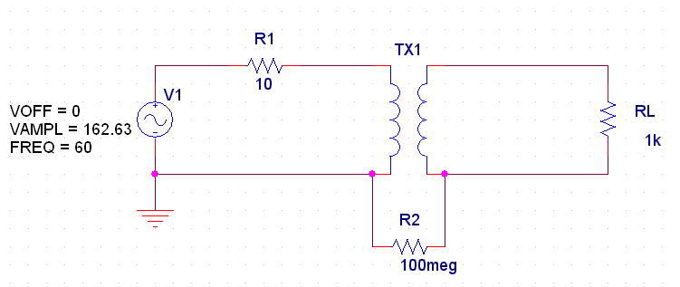
You will need the following parts:

VSIN / SOURCE
XFRM_LINEAR / ANALOG
GND (change name to 0)
R / ANALOG
(10 ohm, 1k, & 100Meg)

- Why did we use the VAMPL value of 162.63 ? That’s 115V_{RMS} converted to V_{P}, SPICE only uses V_{P}, not V_{RMS}

- Double click on the ‘XFRM_LINEAR’ symbol in your schematic, set the value of the field L1_VALUE = 2000H (meaning 2000 Henrys). Realize 2000H is an unrealistic value, but this is necessary to ensure proper simulation

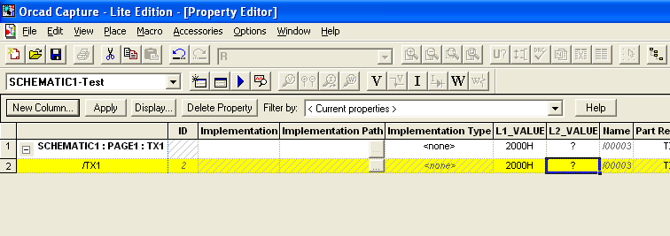

Using the equations above, set the value for L2_VALUE equal to the appropriate value to make a 12.77 : 1 voltage ratio. (Realize that L1_VALUE & L2_VALUE are the inductance of the primary and secondary coil of the transistor). Don’t forget to put the “H” for Henrys unit at the end.

- Put voltage probes on the first and secondary coils:

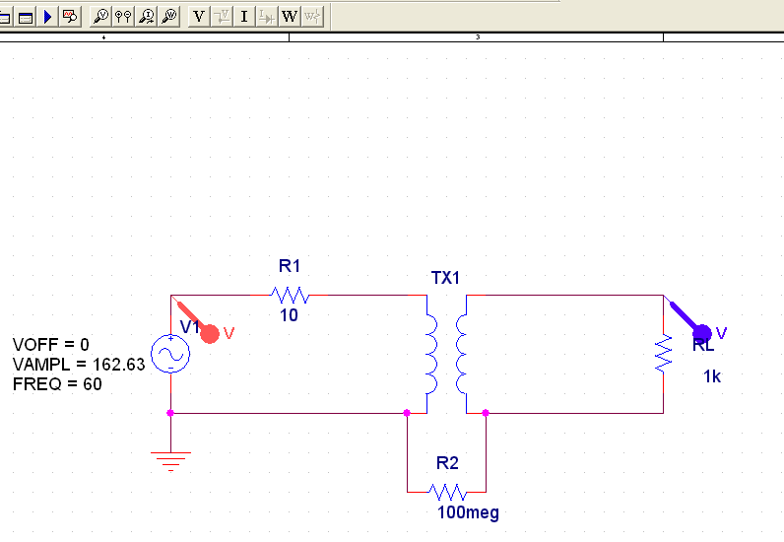

- Create a new simulation profile and name it ‘Lab2a_transformer_transient_sim’

We will perform a transient (time based) simulation. We’d like to see 5 cycles of the sinusoid. Since its frequency is 60Hz, its period must be 16.6ms. To see 5 cycles, we need a transient simulation to run for 83.3ms.

  - Set the ‘Analysis Type’ to: Transient
  - Set the ‘Run Time’ to: 83.3m
  - Then press OK

What this will do (when you run it), is it will plot the voltages at the nodes you have probed vs. time.

- You should have the exact results shown below if you have made the proper inductance ratio:
Interpreting the results:
  - On the curve below, look at the top point ( @20.673ms) V_{P}=162.64 ≈ 115 V_{RMS}
  - Now on the second point (@20.673ms) V_{P}=12.703 ≈ 9 V_{RMS}
  - This is a 12.77:1 voltage ratio as designed!
  - Notice that the transformer hasn’t affected the frequency of the voltage source across the primary coil of the transformer.
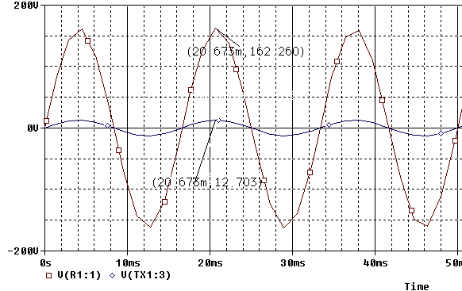

Note: If you design a transformer in SPICE, after you’ve set the TURN ratio, make sure to ALWAYS perform a transient simulation like the one above, to ensure you are getting the amount of voltage you expect out of the secondary coil. This is a mistake many students make.
Part II: Simulating a center-tapped transformer

Background:
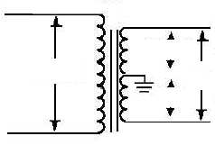
115 V_{RMS}
9 V_{RMS}
9 V_{RMS}
18 V_{RMS}
Primary coil
Secondary coil
TOP HALF
BOTTOM HALF
Fig 2: Step down transformer

Figure 2 above shows the type of transformer that is contained within the ECE 20 parts kit. It is called a ‘Center-tapped step down transformer.’ It still contains only two coils, one primary, one secondary. But now the ‘center’ of the secondary coil has been ‘tapped’ with a wire so that one can take a voltage between the top & center wire of the secondary coil, OR take a voltage between the center & bottom wire of the secondary coil, OR take a voltage between the top and bottom wire of the secondary coil. The result is 3 voltage options. In the case above the figure shows that we can take 9V_{RMS} from the top to center wire, -9V_{RMS} from the bottom wire to the center wire, or 18V_{RMS} from the top to bottom wire of the secondary coil.

The equations remain the same for this type of transformer as in part I of this tutorial. One may think of this as a 115VRMS : 18 VRMS transformer (6.388:1), if one uses the top to bottom wires. Or one may consider this transformer 115V_{RMS} : 9 V_{RMS} transformer (12.77:1), if one uses the top to center wire.

Note: In this example, we are using a 115V_{RMS} to 18V_{RMS} transformer. In a spec sheet for a transformer, if one saw the rating: 115V_{RMS} to 18V_{RMS} C.T. (center tapped), this would indicate that the voltage from the top to the bottom of the secondary coil was 18V_{RMS}.
Part IIa: Simulating a Center Tapped Transformer in SPICE:

Note: The version of Orcad SPICE at GWU has additional part libraries that the Orcad Lite SPICE edition bundled with the Sedra Textbook does not have. The following section contains a technique to create a center tapped transformer that will work in either version of SPICE. If you are using the GWU full version of Orcad SPICE, you may follow this section, or skip to the next to simulate a center tapped transformer. If you are using Orcad Lite, please follow the instructions in this section to simulate a center tapped transformer.

- Build the following schematic in SPICE using three inductors:

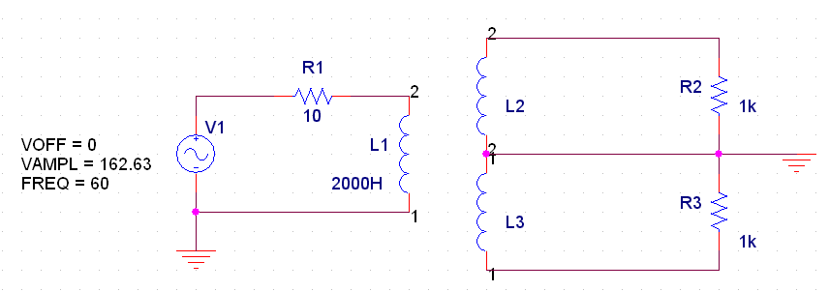
You will need the following parts:

(1) VSIN / SOURCE
(3) L/ANALOG
(2) GND (change name to 0)
(3) R / ANALOG
(10ohm, 1K, and 1K)

The inductors behave as the coils of the transformer. With L1 set at 2000H, determine the inductance ratio necessary (using the first equation from section 1), for the top half of the transformer to have a 12.77:1 turn ratio, and the bottom half of the transformer to have a 12:177:1 turn ratio.

- Add the additional part: K_Linear/Analog to your schematic as follows:

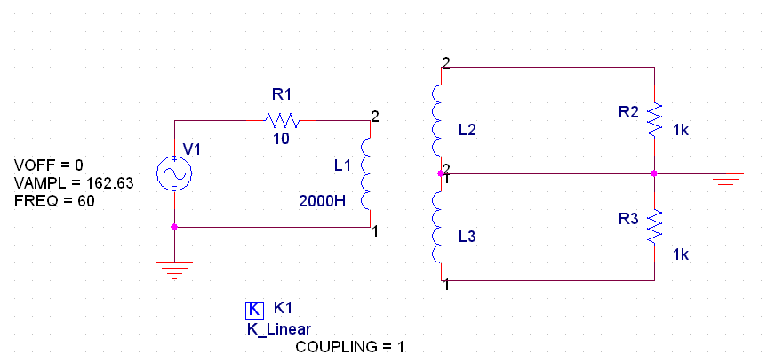

- Double click on the K_Linear/Analog part to bring up its properties window.

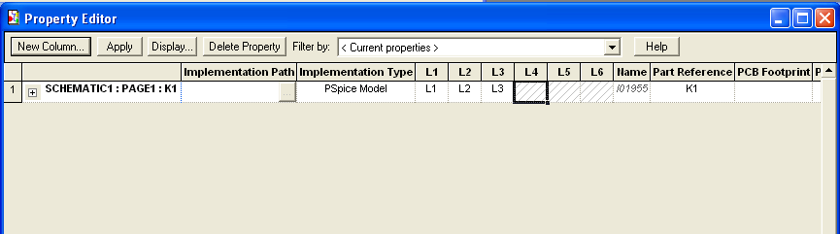
Set the field L1 to be L1, L2 to be L2 and L3 to be L3 (as shown above.

The purpose of the K_Linear part is to setup a coupling of the magnetic fields between inductors L1, L2, and L3. If you are inductors have different instance names (L4, L5, L6) make sure you adjust that properly in the K_Linear part property list.

- Place voltage probes on the resistors at VSIN source (primary coil), and at the top and bottom halves of the secondary coil:

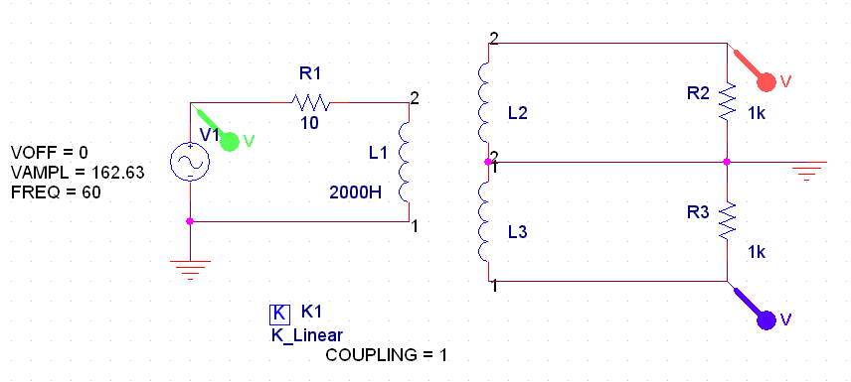

- Perform a transient simulation showing roughly 6 cycles of the output waveforms. Verify that you see 9V_{RMS} across each resistor.

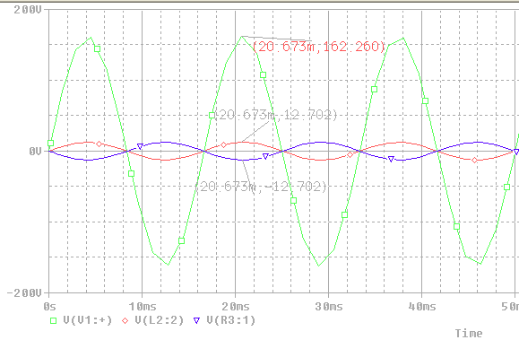
- If you do not see the voltage values as in the figures above, your transformer is not working! Readjust the inductance values until you see the 162.26 Vp : 12.702 Vp ratio as seen above.
- Notice something important, the bottom lead of the transformer produces the INVERSE waveform from the top. It is very important you understand why this is occurring. Understanding this behavior is the key to understanding why a full-wave rectifier circuit behaves the way it does. If you do not understand this graph, take some time to speak with your GTA regarding the observed behavior.

- Rearrange the circuit as follows:
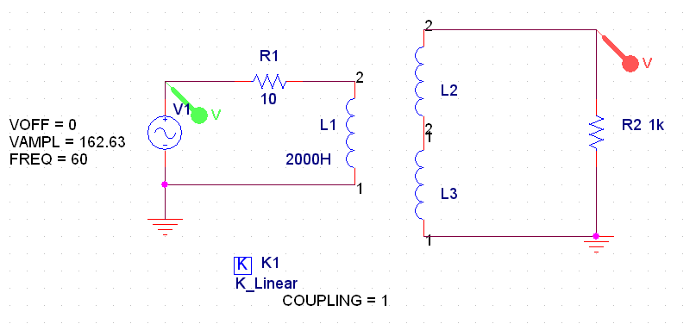

- Perform a transient simulation and verify that you see 18V_{RMS} across the resistor. If you do not see the graph below, you have setup your transformer incorrectly, go back and recheck your steps.

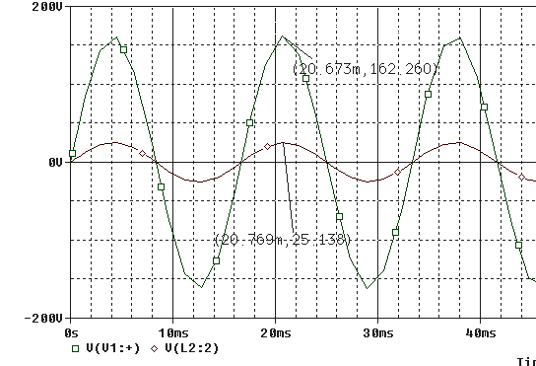

- Place a “W PROBE” (power dissipation probe) on your schematic as follows (notice the W probe must be place ON the resistor itself):

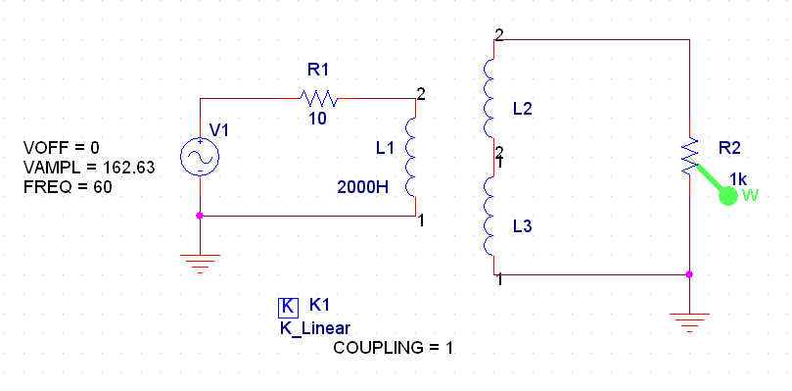
- Run the simulation and observe the following results:

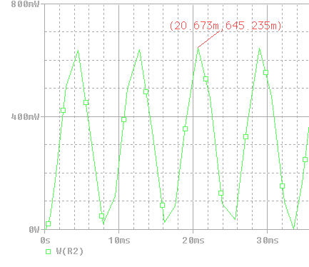

So at the peak secondary coil voltage (Vp=12V), the 1k resistor is dissipating 645.235mWatts of power.
Part IIb: Simulating a Center Tapped Transformer in GWU SPICE:

If you have completed Part IIa, you can skip this portion of the tutorial. This portion of the tutorial is intended for use with the GWU full version of Orcad SPICE. If you have any trouble getting the parts in this portion of the tutorial to simulate, simply use the method discussed in Part IIa.

- Build the following schematic in SPICE:
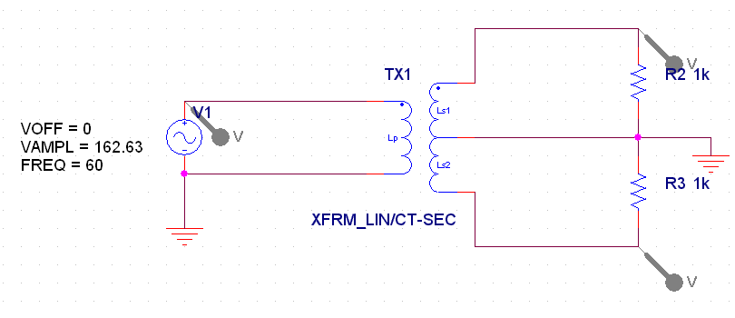
You will need the following parts:

(1) VSIN / SOURCE
(1) XFRM_LIN/CT-SEC/ALNL-MISC
GND (change name to 0)
R / ANALOG
(1K)

Double click on the ‘XFRM_LIN’ symbol in your schematic, set the value of the field LP_VALUE=2000H. Determine the proper value for the LS1_VALUE and the LS2_VALUE to give a 115Vrms : 9Vrms (for the top half) and a 115Vrms : 9Vrms (for the bottom half).

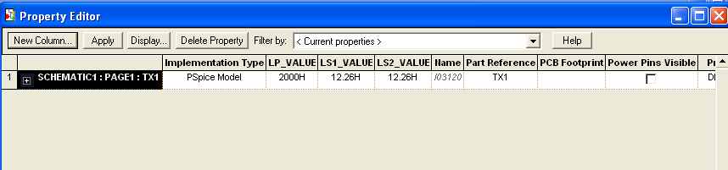

- Perform the transient simulations you see above in Part IIa: step 5, and continue the tutorial from there.

