The George Washington University
School of Engineering and Applied Science
Department of Electrical and Computer Engineering
ECE 20 – SPICE Tutorial 1

Generating an IV Characteristic Curve for a Diode
Performing a DC Sweep Simulation in SPICE

Description:

In this tutorial, we will generate the IV Curve for the 1N4002 diode using PSPICE Lite v9.2. This will tell us the voltages and currents we can apply to the 1N4002 diode in the lab. The type of simulation we will be performing is referred to as a parametric sweep.

- Start PSPICE (Cadence CIS) and create a BLANK project

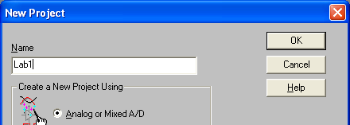

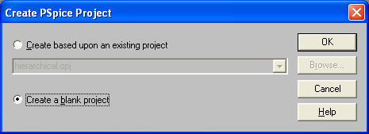

- Build the following schematic:

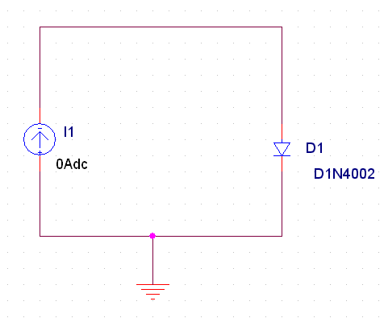
You will need the following parts:

IDC
D1N4002
GND

2a) If you cannot find part D1N4002, you must add the correct library that contains the diode as follows:
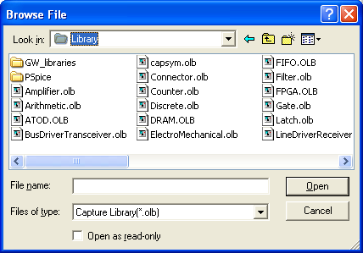
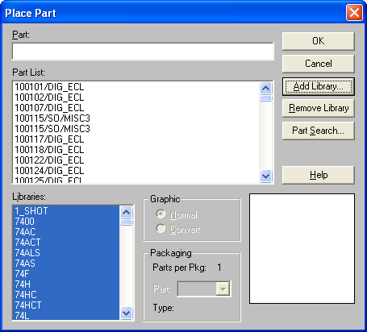

-Double click on the “PSpice” folder, and choose the file named: eval.olb, then click “OPEN”
-Now type in DN1N4002 and it will open

- Double click on the ‘GND’ symbol in your schematic, change the “NAME” field to be zero:

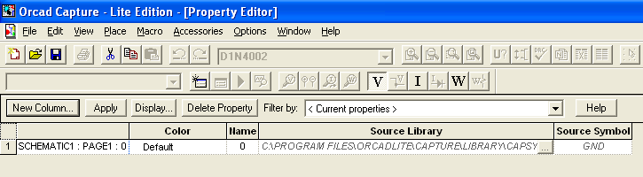

Then close the window. This is very important as you might see an error indicating a ‘floating ground’ if you do not follow this step.

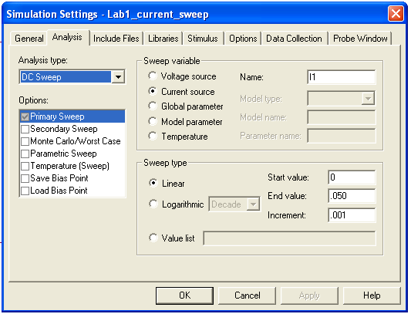
- Create a new simulation profile and name it ‘Lab1_current_sweep’

  - Set the ‘Analysis Type’ to: DC Sweep
  - Set the ‘Sweep Variable’ to: Current Source, then set the “NAME” to match the name of your current source, in your schematic.
  - Set the ‘Start Value’ to: 0
  - Set the ‘End Value’ to .050
  - Set the ‘Increment’ to .001
  - Then press OK

What this will do (when you run it), is to ‘sweep’ the value of the DC Current Source (I1) from 0 to 50mA, in 1mA increments.

- Run the simulation. It will come up with a blank black window, with I_I1 as the x-axis. The ‘parameter’ you sweep, will always come up as the x-axis in SPICE. But, since this is an IV Curve, we typically want Voltage to be on the x-axis. Follow the following steps to change this:
  - From the simulation results window, choose: Plot->Axis Settings…
  - Click on the “AXIS Variable” button
  - Choose V(D1:1) to be the ‘Trace Expression’
  - Press OK
  - The x-axis should now be the V(D1:1) or the ‘voltage across the diode D1’ in your schematic
  - Now we want to add the value of the current source I1, as the y-axis
  - From the simulation results window, choose: Trace->Add Trace…
  - Choose the name of your ‘swept’ current source: I_I1
  - Press OK
  - You should now have a typical diode IV Curve on the screen as seen below

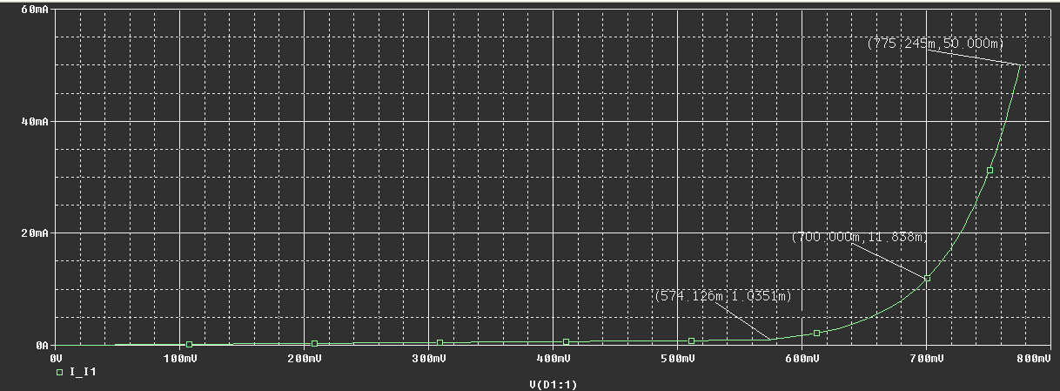
Classic Diode IV Curve

- Interpreting the results
  - On the curve above, look at the top point ( I1 = 775.249mA, VD1 = 50mA)
  - This means that when we forced ‘50mA’ of current into our diode, their was a voltage drop of .775 V across it at that time.

- Plotting the Reverse Bias Current
  - The plot above shows the ‘forward IV characteristic’ for the diode.
  - If one wanted to find the ‘reverse IV characteristic’ simply choose a negative ‘start value’ for the swept current
  - An example of what the complete reverse + forward IV characteristic curve for the diode would look like is this (Current swept from -1A to +1A) :

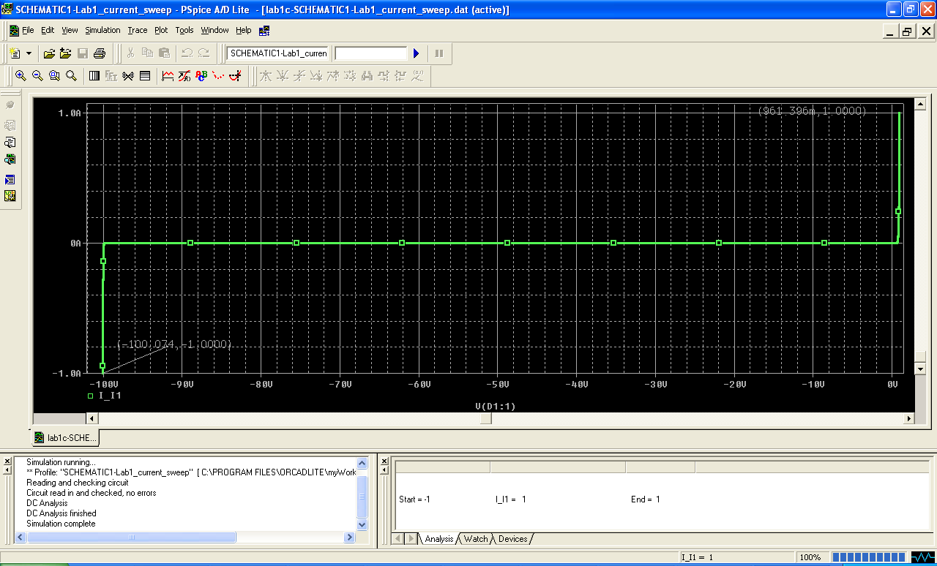

  - Compare the full graph above to the specification sheet for the 1N4002 diode.
    - Spec: Forward Voltage: V_{FM} = 1.0 V @ I_{F} = 1.0A (see chart below)
    - Spec: Reverse Voltage: V_{R} = 100V
    - These two ‘extreme’ values are shown on the graph above:
Graph: when I1 = 1A, VD= .961V
Graph: when I1 = -1A, VD = -100V
    - So it lines up nicely with the manufacture’s specification!

