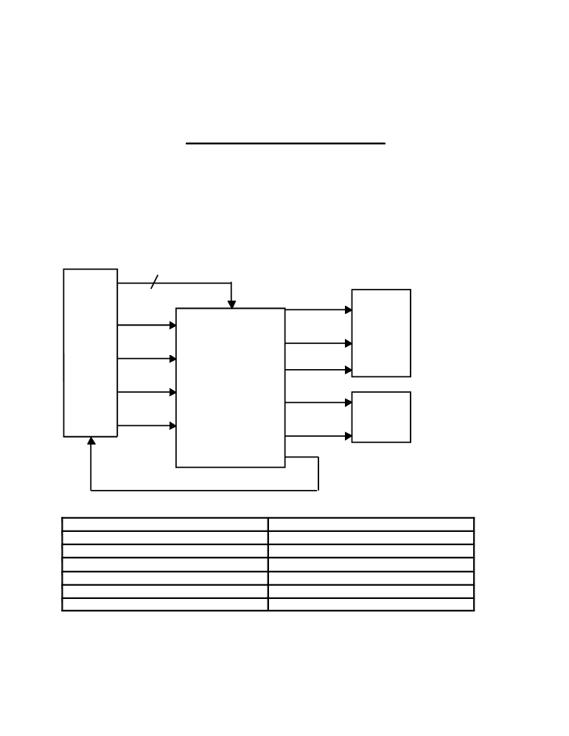

THE GEORGE WASHINGTON UNIVERSITY
DEPARTMENT OF ELECTRICAL AND COMPUTER ENGINEERING
ECE 122-FALL 2010
FINAL PROJECT-OPTION 3
VENDING-MACHINE CONTROL UNIT

The customers of KA*Tech Corporation were quite impressed by your performance on the multi-function register project. Consequently, the company was awarded a new project to design, implement and document a prototype circuit that will control the operation of vending machines. In order to control costs, the customer requires the control circuit to be implemented in a single chip. The
only external components allowed are discrete resistors and capacitors. This control unit must
interface with three auxiliary units: (i) the coin-input and drink selection unit, (ii) the change-
dispensing unit, and (iii) the drink-dispensing unit, as shown in the following block-diagram:

DT 2

ND
Coin
input and
drink DD
selection
unit
QD Vending-machine
control unit
CR

NC

DC

QC

DR1

DR2

CC

Change
dispensing
unit

Drink
dispensing
unit

Inputs to control unit Outputs from control unit

ND = Nickel deposited CC = Collect coins

DD = Dime deposited NC = Nickel change

QD = Quarter deposited DC = Dime change

CR = Coin return QC = Quarter change

DT1 = Drink type 1 DR1 = Dispense drink type 1

DT2 = Drink type 2 DR2 = Dispense drink type 2

Although the operation of a vending machine is familiar, let us review a typical transaction. A
series of coins, restricted to nickels, dimes, or quarters is inserted one at a time into the coin

GWU/SEAS/ECE 122: Fall 2000; Prepared by: M. Afridi and C. E. Korman

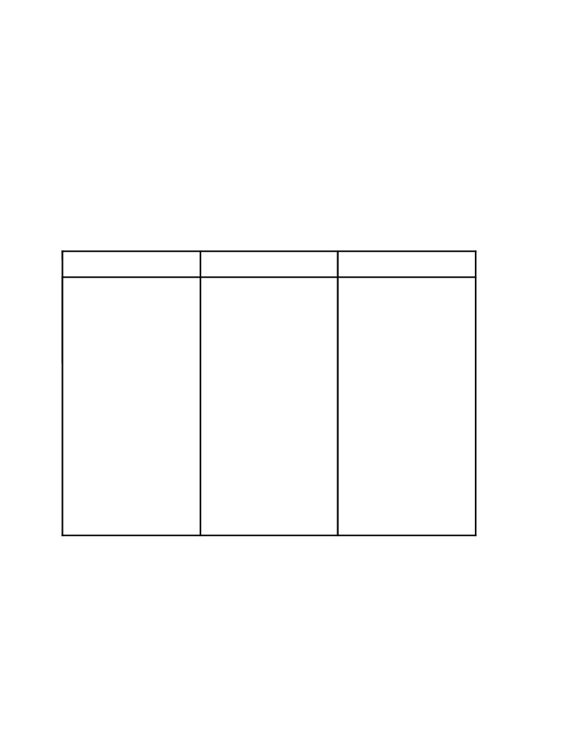
return button activates (VH)

input unit. This unit holds them in a temporary location and produces a pulse on one of its output lines indicating the value of each coin inserted. The vending machine offers two choices of drinks. The first drink, DT1, costs sixty cents and the second drink, DT2, costs eighty-five cents.
The buyer may push the coin-return button at any time before the release of a drink, generating a
signal to the controller indicating that all money has been returned. The buyer may press the
appropriate drink type at any given time. If enough money was deposited into the machine then
the appropriate drink and change is released. Obviously, the controller must generate output
signals to the drink and change dispensing units. In addition, once a drink is released, a signal is
generated causing the coin-input unit to transfer all coins from the temporary location to the
permanent location.

Auxiliary-unit input-output signal specifications:

Coin - input and drink Change dispensing unit Drink dispensing unit
selection unit
ND, DD, QD signals: unit This unit has three input This unit has two inputs
will accept nickels, dimes lines: one for nickels (NC), (DR1, DR2) and dispenses

or quarters and produce a
200ms pulse (VH) on line corresponding to that coin type; Outputs will be
inactive (VL) for at least
500ms between successive
pulses.
CR signal: pushing the coin

the coin return line as long as button is pushed.
CC signal: a 200ms pulse (VH) on this line causes deposited coins to be
collected.
DT1, DT2 signals: a 200ms pulse is generated (VH) to indicate the drink type.
one for dimes (DC) and one one drink for each input
for quarters (QC); one coin pulse (VH) lasting longer
of appropriate value is than 200ms.
released for each input
pulse (VH) lasting longer
than 200ms; inputs must be
inactive (VL ) for at least
200ms between pulses.

It is your responsibility to make sure that the above pulses are generated and the timing requirements are met. The only input one may assume from the user is an arbitrary pulse trigger. You must implement this circuit in 0.8 um HP CMOS n-well technology. You may assume that a 5 VDC power supply is available. In your documentation you must clearly demonstrate the correct operation of this circuit for at least five different test cases (coin input sequence and drink type).

GWU/SEAS/ECE 122: Fall 2000; Prepared by: M. Afridi and C. E. Korman

