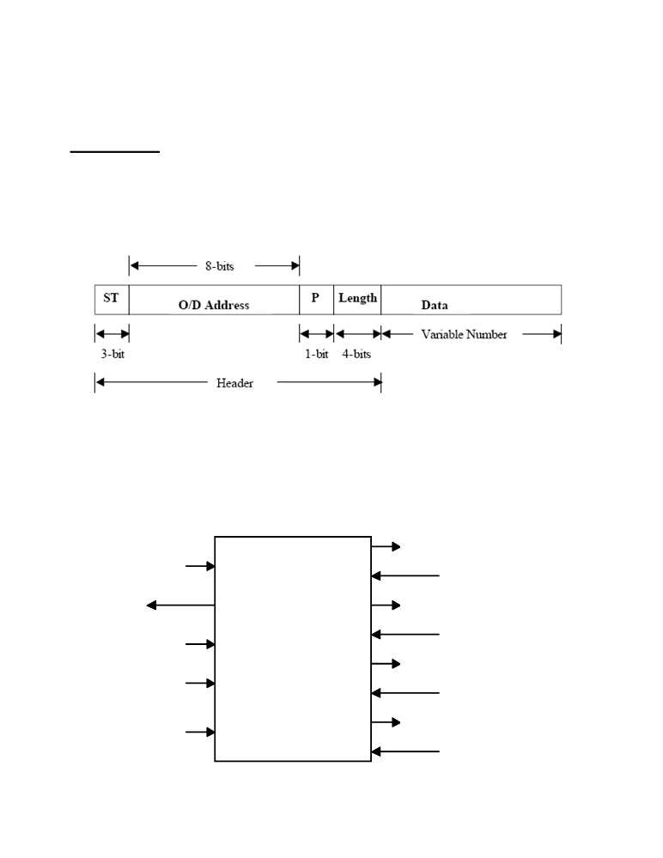

THE GEORGE WASHINGTON UNIVERSITY
DEPARTMENT OF ELECTRICAL AND COMPUTER ENGINEERING
ECE 122-FALL 2009
FINAL PROJECT-OPTION 1

ROUTER CHIP
The customers of KA*Tech Corporation were quite impressed by your performance on the multi function register. Consequently, the company awarded a new project to design, implement and document a prototype circuit that will control the operation of a mini-router. The role of the router is to route packets of information on the Internet to the intended destination. For the purposes of this project, we will consider a packet to be as follows:

ST = 1: Start bits of a new packet. The network line is set to zero when there is no packet. Therefore, this field signals the router that a new packet has arrived.
O/D Address = The first 4-bits are the Originator and the second 4-bits are the Destination addresses.
P = Priority bit: zero means low priority and one means high priority. Length = Indicates the number of bits in the data field
Data = Variable length data (in this case 1 to 16-bits).

RT0

I

SS

CLK

VDD

GND

Route-Me
Chip

KA Electronics

S0
RT1
S1
RT2
S2
RT3
S3

Input/Output block diagram of the router chip

Prepared by: C. E. Korman and M. Afridi, November 15, 2000.

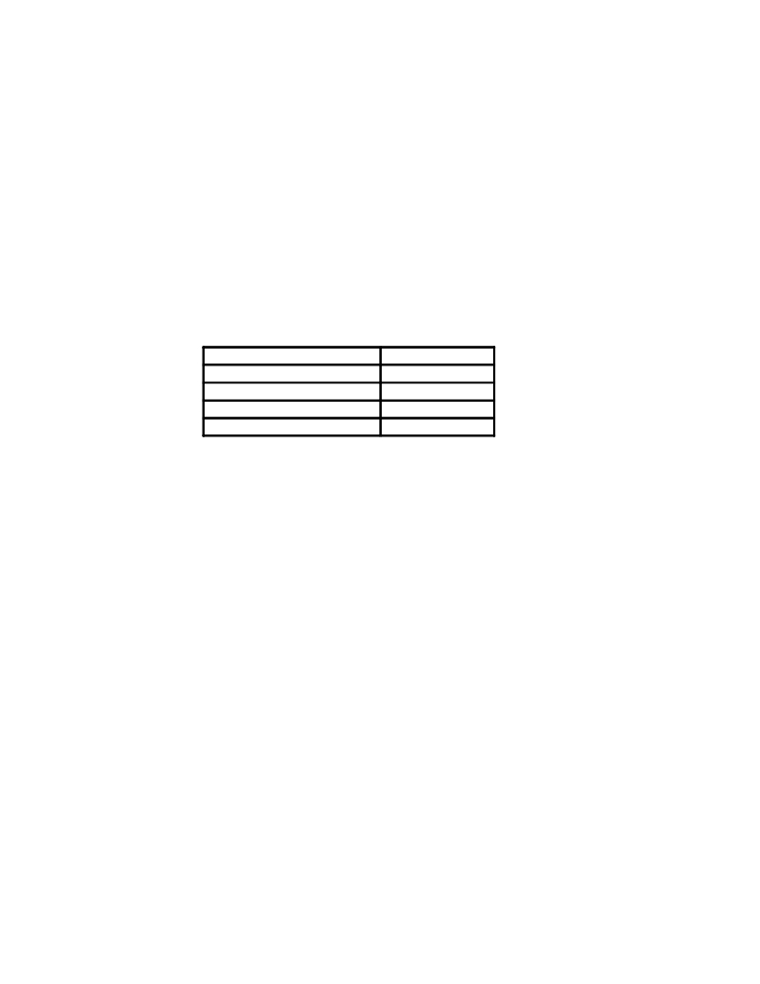

Description:
The figure above shows the block diagram of the router. You may assume that the packet arrivals are synchronized with an external network clock (CLK) in such a way that the rise of the clock is in the center of each arriving bit. Each router on the network has one serial input (I) and four serial output ports (RT0, RT1, RT2, RT3) to route the packets. If the router is unable to route a packet, it stores it in a buffer, called a queue. The mini-router specifications require a buffer that can store up to four packets. Once the output ports are ready, the router will clear its queue based on a first in first out (FIFO) basis. Each router calculates its load based on the status of its buffer. In order to indicate the status of its queue to other routers, a one-bit signal is employed: one indicates that the router is busy and zero indicates that the router is ready to receive packets.
Each router directs the incoming packets based on the destination address. Typically, a router has a look up table (LUT) which is used to map a destination address to a router port. In this project we will use the most significant two bits of the destination address to select the output port. The routing must be done according to the following table:

Destination Address Router Number
00 xx 0
01 xx 1
10 xx 2
11 xx 3

Other Specifications:

Design, layout, extract and simulate a CMOS router chip with minimum core area and optimum power consumption. You must implement this circuit in 0.8 um HP CMOS n-well technology. You may assume that a 5 VDC power supply is available. The length of each bit in the packet is 10ns wide. All I/O must be buffered. In your documentation you must clearly demonstrate the correct operation of this circuit for at least for the following cases:

  - All destination routers busy: show that the buffers will accumulate up to four packets and then the circuit sets the output port SS to one.
  - Some destination routers available: buffer only accumulates when packet destination is to a busy router but otherwise transmits to the available one(s).
  - All routers available. No buffering.
.

Prepared by: C. E. Korman and M. Afridi, November 15, 2000.

