The George Washington University
Department of ECE
ECE 001/002
Intro: Electrical & Computer Engineering

Group Number : _______
Group Members: _________________________
_________________________
_________________________
_________________________
_________________________

Please assign one member of your group to be in charge of one of the following tasks, with one other person as backup:

 | Main Member | Back-up Member
Kit Coordinator

Demonstration Coordinator

Presentation Coordinator

Report Coordinator

Please note that the coordinator for each task is not in charge of his/her particular task, but rather it is his/her responsibility that everyone participates in the given task.

PART LIST – BOTBALL KIT

Please make sure that the following parts are in each of the kits you receive. At the end of the semester, each group will be help responsible for broken/missing parts.

In small white box:

- Handy Board system which include:

- Handy board (This may be in the lab already)
- Ac adapter (This ma also be in the lab already)
- Interface board
- Serial connection cables (This may be connected to the PC)
- Board connection cable (RJ-11 on both ends)
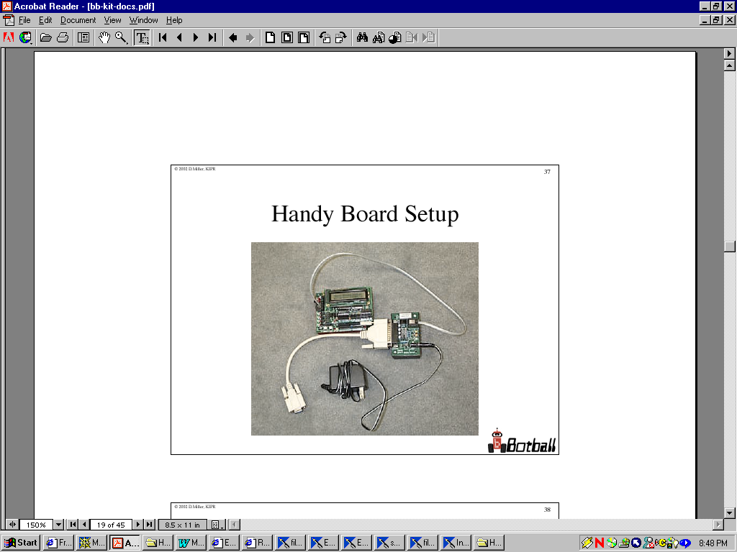

- 2 LEGO motors, and their corresponding motor connectors.
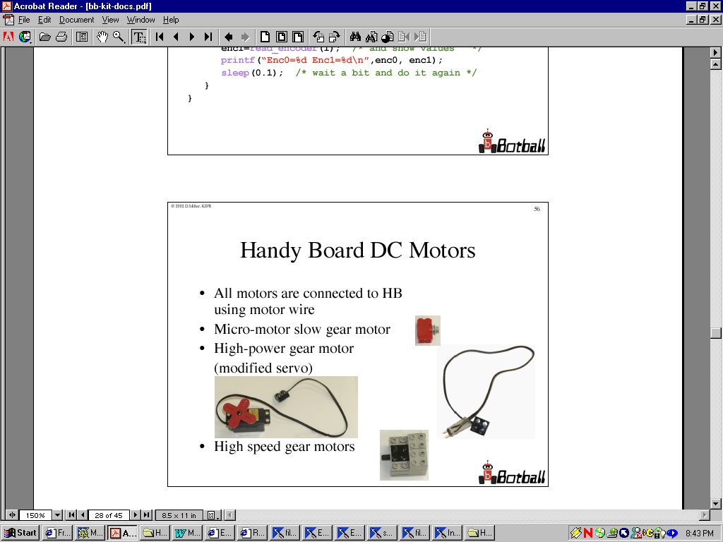

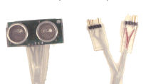
- 1 sonar range sensor

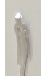
- 2 light sensors

- 2 IR (Top Hat) sensors

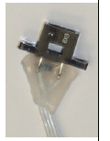

- 2 Optical Range Sensors

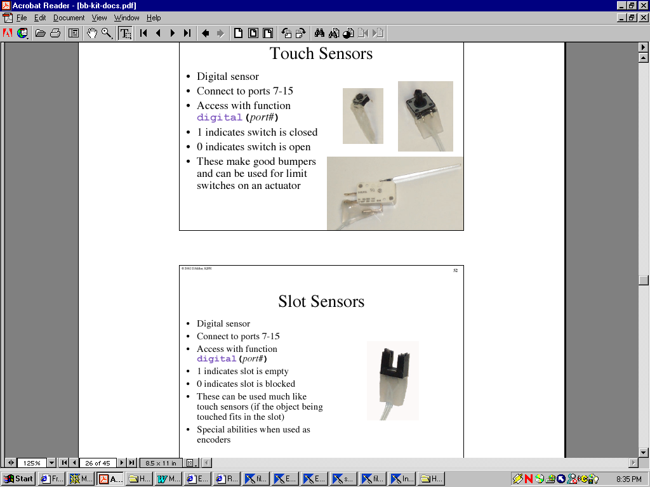
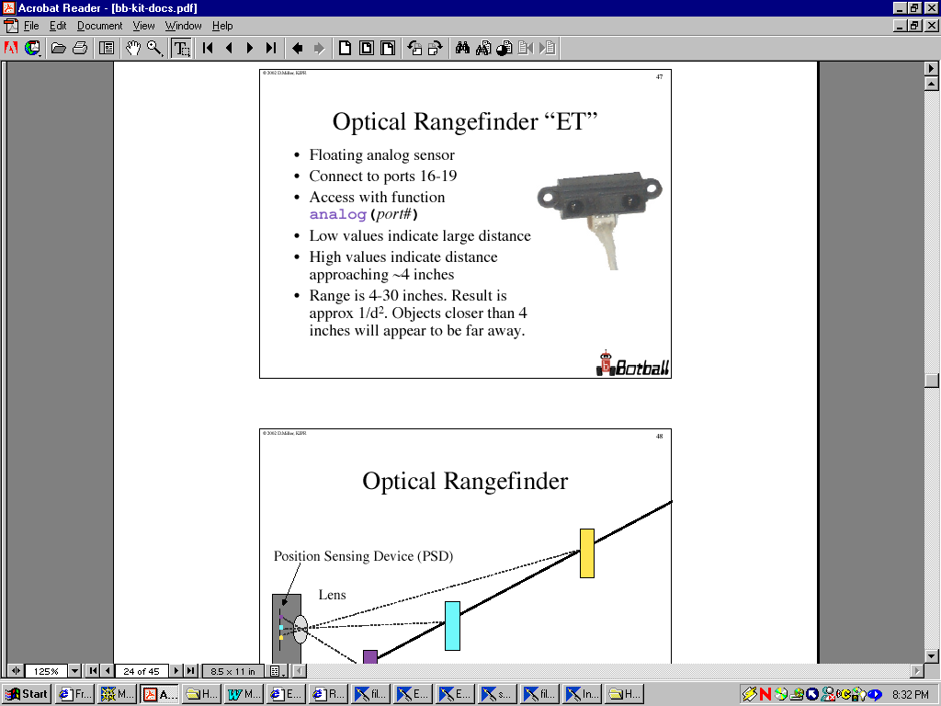

- 2 touch sensors

In big white box:

- Over 1200 pieces of assorted LEGO building components

