Group Names: ____________

____________

____________

____________

____________
GROUP #: ________

PART LIST – BOTBALL KIT

Check your kits for the following components:

In small white box:

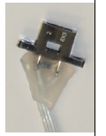
- 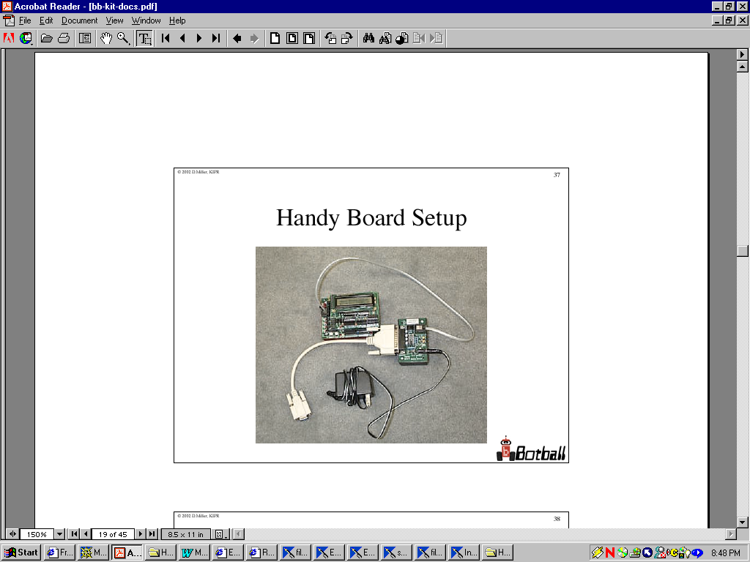Handy Board system which include: ● 2 IR Top Hat Sensors
Handy board
Ac adapter
Interface board
Serial connection cables (DB9-DB25, DB9-DB9)
Board connection cable (RJ-11 on both ends)

- 2 LEGO motors, and their ● 2 Optical Range Finders
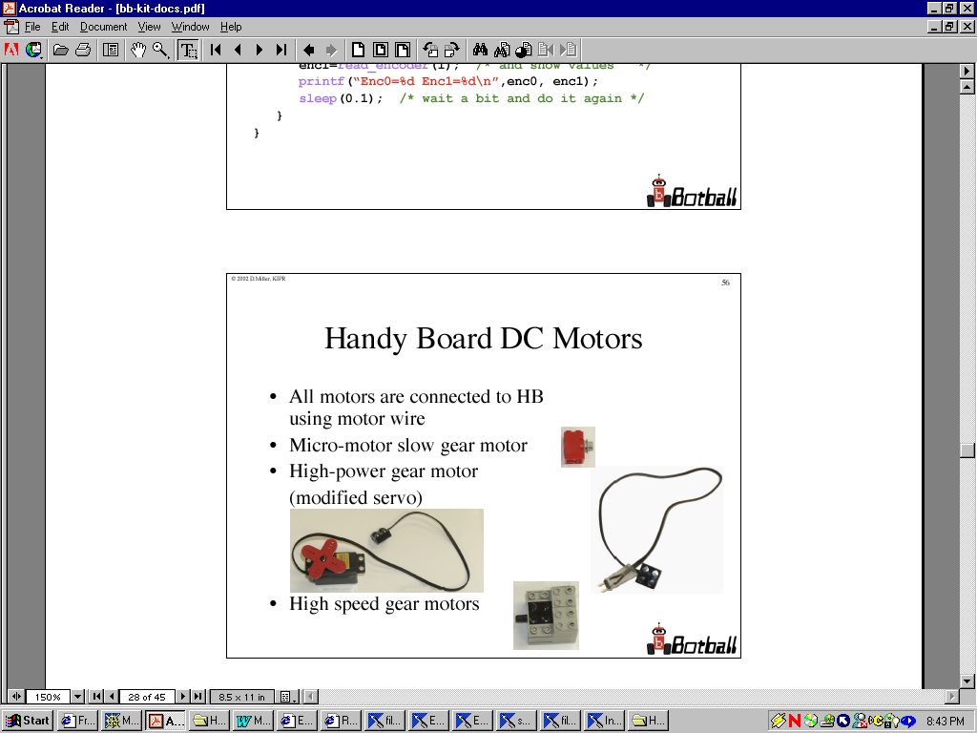
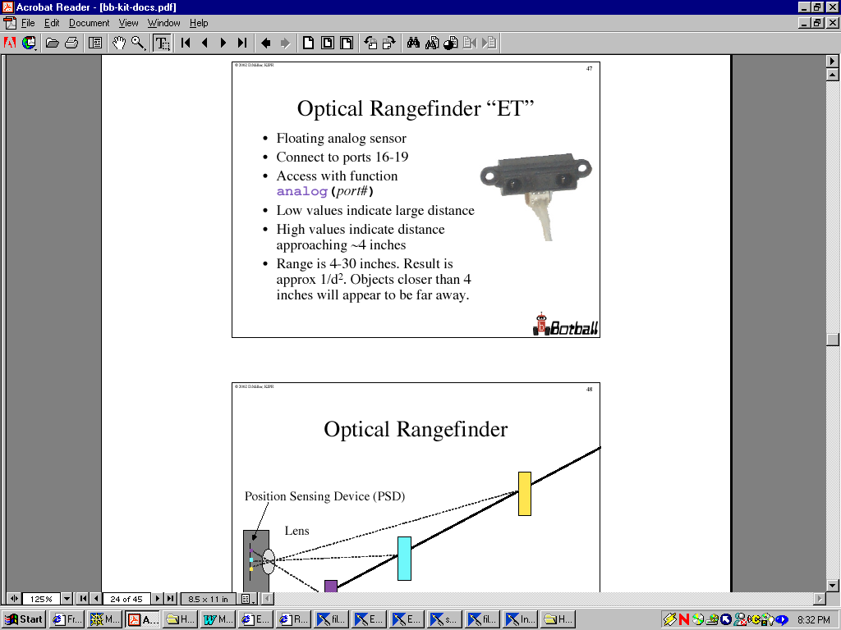corresponding motor connectors.

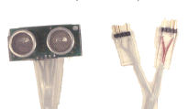
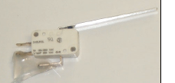
- 1 sonar range sensor ● 2 Touch Sensor

Parts not working correctly:
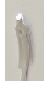
- 2 light sensors

