The George Washington University
Department of ECE
ECE 001-10
Intro: Electrical & Computer Engineering
Fall 2002

PART LIST – BOTBALL KIT

In small white box:

- Handy Board system which include:

-Handy board
-Ac adapter
-Interface board
-Serial connection cables (DB9-DB25, DB9-DB9)
-Board connection cable (RJ-11 on both ends)
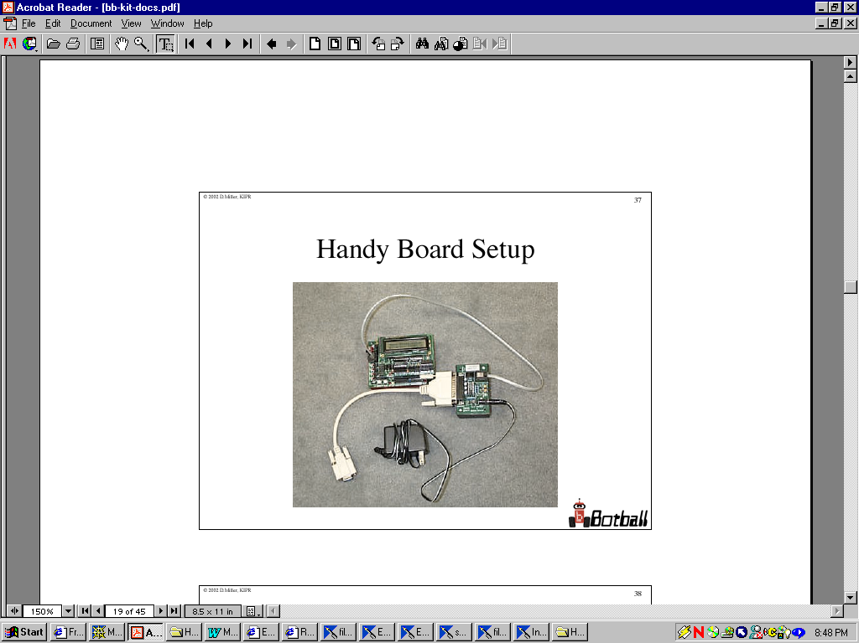

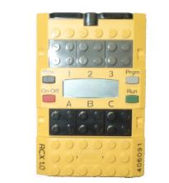
1 RCX 1.0 controller

- 1 LEGO remote control
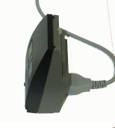

- 5 servo motors

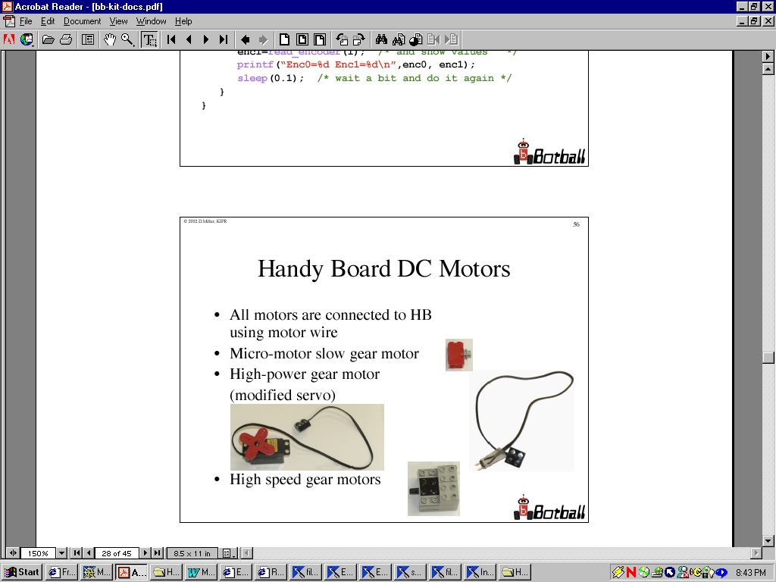
- 4 LEGO motors

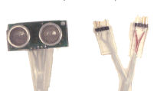
- 1 sonar range sensor

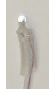
- 3 light sensors

- 2 IR sensors

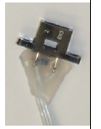

- 2 Optical Range Sensors

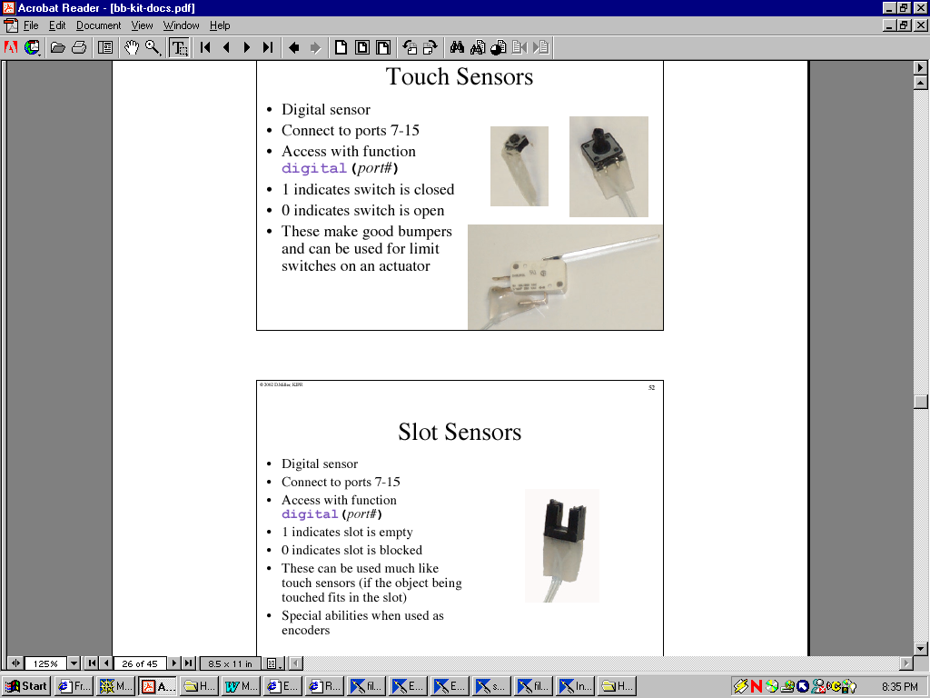
- 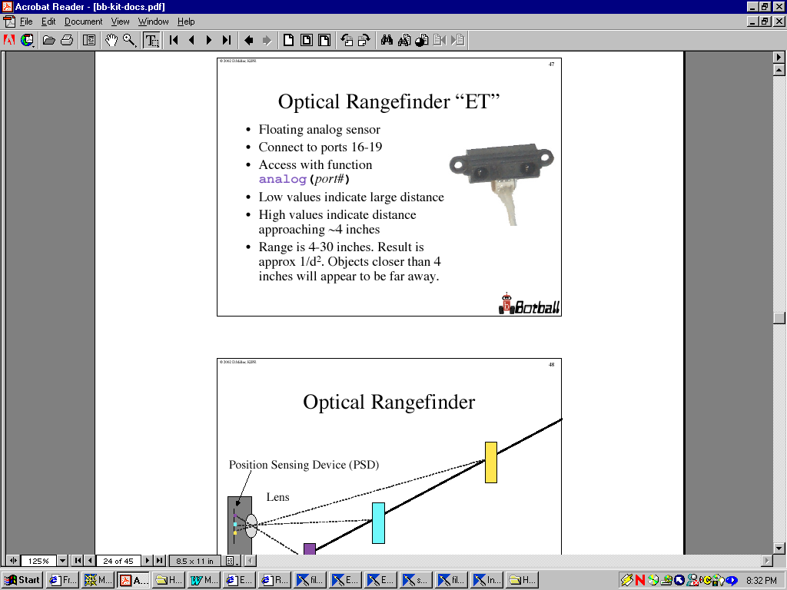2 Slot sensors

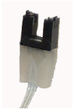

- 6 touch sensors ( 3 kinds)

- 1 9V battery and 6 AA size batteries

- 1 CD-ROM containing documentation of the kit

In big white box:

- Over 1200 pieces of assorted LEGO building components

- 1 USB PDA Adapter

- 1 Lego Controller

