Branch and Bound

 Definitions:

- Branch and Bound is a state space search method in which all the children of a node are generated before expanding any of its children.

- Live-node: A node that has not been expanded.

- It is similar to backtracking technique but uses BFS-like search.

1
2
3
4
5
6
7
8
9
1
2
3
4
5
6
7
8
9
1
2
3
4
5

Live Node: 2, 3, 4, and 5
FIFO Branch & Bound (BFS)
Children of E-node are inserted in a queue.
LIFO Branch & Bound (D-Search)
Children of E-node are inserted in a stack.

- Dead-node: A node that has been expanded
- Solution-node

 LC-Search (Least Cost Search):

- The selection rule for the next E-node in FIFO or LIFO branch-and-bound is sometimes “blind”. i.e. the selection rule does not give any preference to a node that has a very good chance of getting the search to an answer node quickly.

- The search for an answer node can often be speeded by using an “intelligent” ranking function, also called an approximate cost function $\overset{\hat{}}{C}$

- Expanded-node (E-node): is the live node with the best $\overset{\hat{}}{C}$ value

 Requirements

- Branching: A set of solutions, which is represented by a node, can be partitioned into mutually exclusive sets. Each subset in the partition is represented by a child of the original node.

- Lower bounding: An algorithm is available for calculating a lower bound on the cost of any solution in a given subset.

 Searching: Least-cost search (LC)

- Cost and approximation

- Each node, X, in the search tree is associated with a cost: C(X)

- C(X) = cost of reaching the current node, X (E-node), from the root + the cost of reaching an answer node from X.

C(X) = g(X) + h(X)

- Get an approximation of C(x), $\overset{\hat{}}{C}$ (x) such that
$\overset{\hat{}}{C}$ (x) ≤C(x), and
$\overset{\hat{}}{C}$ (x) = C(x) if x is a solution-node.

- The approximation part of $\overset{\hat{}}{C}$ (x) is

h(x)=the cost of reaching a solution-node from X,
not known.

- Least-cost search:
The next E-node is the one with least $\overset{\hat{}}{C}$

 Example: 8-puzzle

- Cost function: $\overset{\hat{}}{C}$ = g(x) +h(x)

where
h(x) = the number of misplaced tiles
and g(x) = the number of moves so far

- Assumption: move one tile in any direction cost 1.

12356784
12358674
Initial State
Final State

12358674
12356784
12356478
12356784
12563784
12358674
12356784
13526784
12358674

Note: In case of tie, choose the leftmost node.
 Algorithm:
/* live_node_set: set to hold the live nodes at any time */
/* lowcost: variable to hold the cost of the best cost at any given node */
Begin
Lowcost = ∞;
While live_node_set ≠∞ do
- choose a branching node, k, such that
k ∈live_node_set; /* k is a E-node */
- live_node_set= live_node_set - {k};
- Generate the children of node k and the corresponding lower bounds;
S_{k}={(i,z_{i}): i is child of k and z_{i} its lower
bound}
- For each element (i,z_{i}) in S_{k} do
- If z_{i} > U
- then
- Kill child i; /* i is a child node */
- Else
If child i is a solution
Then
U =z_{i}; current best = child i;
Else
Add child i to live_node_set;
Endif;
Endif;
- Endfor;
Endwhile;
 Travelling Salesman Problem: A Branch and Bound algorithm

- Definition: Find a tour of minimum cost starting from a node S going through other nodes only once and returning to the starting point S.

- Definitions:

- A row(column) is said to be reduced iff it contains at least one zero and all remaining entries are non-negative.

- A matrix is reduced iff every row and column is reduced.

- Branching:

- Each node splits the remaining solutions into two groups: those that include a particular edge and those that exclude that edge

- Each node has a lower bound.

- Example: Given a graph G=(V,E), let <i,j> ∈ E,
All Solutions
Solutions with <i,j>
Solutions without <i,j>
L1
L
L2

- Bounding: How to compute the cost of each node?

- Subtract of a constant from any row and any column does not change the optimal solution (The path).

- The cost of the path changes but not the path itself.

- Let A be the cost matrix of a G=(V,E).

- The cost of each node in the search tree is computed as follows:

- Let R be a node in the tree and A(R) its reduced matrix
- The cost of the child (R), S:
- Set row i and column j to infinity
- Set A(j,1) to infinity
- Reduced S and let RCL be the reduced cost.
- C(S) = C(R) + RCL+A(i,j)

- Get the reduced matrix A' of A and let L be the value subtracted from A.
- L: represents the lower bound of the path solution
- The cost of the path is exactly reduced by L.

- What to determine the branching edge?

  - The rule favors a solution through left subtree rather than right subtree, i.e., the matrix is reduced by a dimension.

  - Note that the right subtree only sets the branching edge to infinity.

  - Pick the edge that causes the greatest increase in the lower bound of the right subtree, i.e., the lower bound of the root of the right subtree is greater.

    - Example:
- The reduced cost matrix is done as follows:
- Change all entries of row i and column j to infinity
- Set A(j,1) to infinity (assuming the start node is 1)
- Reduce all rows first and then column of the resulting matrix

- Given the following cost matrix:
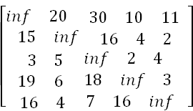

- State Space Tree:
Vertex = 3
Vertex = 5
6
7
8
10
4
5
35
53
25
Vertex = 2
Vertex = 5
Vertex = 3
3
Vertex = 2
Vertex = 5
Vertex = 4
Vertex = 3
28
50
36
52
28
25
1
2
31
9
11
28
Vertex = 3

- The TSP starts from node 1: Node 1
  - Reduced Matrix: To get the lower bound of the path starting at node 1
    - Row # 1: reduce by 10
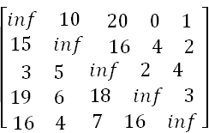

    - Row #2: reduce 2
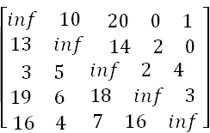

    - Row #3: reduce by 2
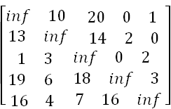

    - Row # 4: Reduce by 3:
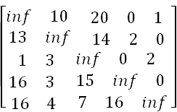
    - Row # 4: Reduce by 4
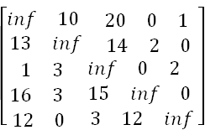
    - Column 1: Reduce by 1
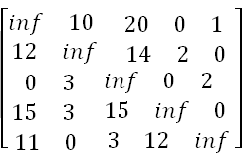

    - Column 2: It is reduced.
    - Column 3: Reduce by 3
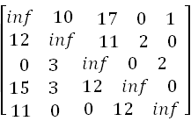

    - Column 4: It is reduced.
    - Column 5: It is reduced.
    - The reduced cost is: RCL = 25
    - So the cost of node 1 is:
      - Cost(1) = 25
    - The reduced matrix is:
cost(1) = 25

- Choose to go to vertex 2: Node 2
- Cost of edge <1,2> is: A(1,2) = 10
- Set row #1 = inf since we are choosing edge <1,2>
- Set column # 2 = inf since we are choosing edge <1,2>
- Set A(2,1) = inf
- The resulting cost matrix is:
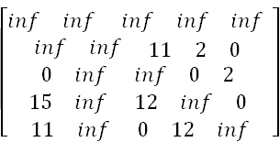

- The matrix is reduced:
  - RCL = 0
- The cost of node 2 (Considering vertex 2 from vertex 1) is:
    - Cost(2) = cost(1) + A(1,2) = 25 + 10 = 35

- Choose to go to vertex 3: Node 3
- Cost of edge <1,3> is: A(1,3) = 17 (In the reduced matrix
- Set row #1 = inf since we are starting from node 1
- Set column # 3 = inf since we are choosing edge <1,3>
- Set A(3,1) = inf
- The resulting cost matrix is:
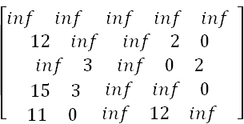
- Reduce the matrix:
  - Rows are reduced
  - The columns are reduced except for column # 1:
    - Reduce column 1 by 11:
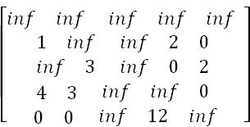

- The lower bound is:
  - RCL = 11
- The cost of going through node 3 is:
  - cost(3) = cost(1) + RCL + A(1,3) = 25 + 11 + 17 = 53

- Choose to go to vertex 4: Node 4
  - Remember that the cost matrix is the one that was reduced at the starting vertex 1
  - Cost of edge <1,4> is: A(1,4) = 0
  - Set row #1 = inf since we are starting from node 1
  - Set column # 4 = inf since we are choosing edge <1,4>
  - Set A(4,1) = inf
  - The resulting cost matrix is:
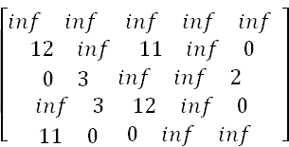
  - Reduce the matrix:
    - Rows are reduced
    - Columns are reduced
  - The lower bound is: RCL = 0
  - The cost of going through node 4 is:
    - cost(4) = cost(1) + RCL + A(1,4) = 25 + 0 + 0 = 25

- Choose to go to vertex 5: Node 5
  - Remember that the cost matrix is the one that was reduced at starting vertex 1
  - Cost of edge <1,5> is: A(1,5) = 1
  - Set row #1 = inf since we are starting from node 1
  - Set column # 5 = inf since we are choosing edge <1,5>
  - Set A(5,1) = inf
  - The resulting cost matrix is:
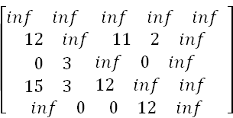
  - Reduce the matrix:
    - Reduce rows:
      - Reduce row #2: Reduce by 2
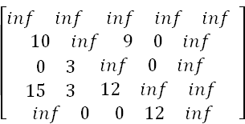
      - Reduce row #4: Reduce by 3
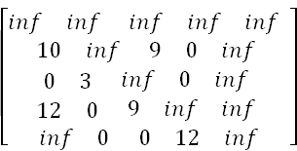
    - Columns are reduced

  - The lower bound is:
    - RCL = 2 + 3 = 5
  - The cost of going through node 5 is:
    - cost(5) = cost(1) + RCL + A(1,5) = 25 + 5 + 1 = 31

- In summary:
  - So the live nodes we have so far are:
    - 2: cost(2) = 35, path: 1->2
    - 3: cost(3) = 53, path: 1->3
    - 4: cost(4) = 25, path: 1->4
    - 5: cost(5) = 31, path: 1->5
  - Explore the node with the lowest cost: Node 4 has a cost of 25
  - Vertices to be explored from node 4: 2, 3, and 5
  - Now we are starting from the cost matrix at node 4 is:

Cost(4) = 25

- Choose to go to vertex 2: Node 6 (path is 1->4->2)
  - Cost of edge <4,2> is: A(4,2) = 3
  - Set row #4 = inf since we are considering edge <4,2>
  - Set column # 2 = inf since we are considering edge <4,2>
  - Set A(2,1) = inf
  - The resulting cost matrix is:
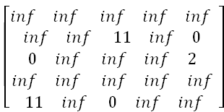

  - Reduce the matrix:
    - Rows are reduced
    - Columns are reduced
  - The lower bound is: RCL = 0
  - The cost of going through node 2 is:
    - cost(6) = cost(4) + RCL + A(4,2) = 25 + 0 + 3 = 28

- Choose to go to vertex 3: Node 7 ( path is 1->4->3 )
  - Cost of edge <4,3> is: A(4,3) = 12
  - Set row #4 = inf since we are considering edge <4,3>
  - Set column # 3 = inf since we are considering edge <4,3>
  - Set A(3,1) = inf
  - The resulting cost matrix is:
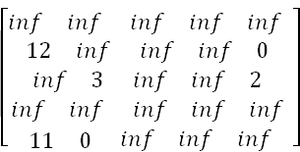
  - Reduce the matrix:
    - Reduce row #3: by 2:
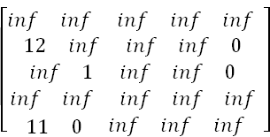
    - Reduce column # 1: by 11
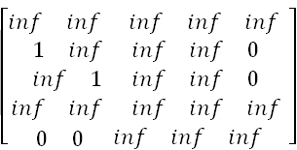
  - The lower bound is: RCL = 13
  - So the RCL of node 7 (Considering vertex 3 from vertex 4) is:
    - Cost(7) = cost(4) + RCL + A(4,3) = 25 + 13 + 12 = 50

- Choose to go to vertex 5: Node 8 ( path is 1->4->5 )
  - Cost of edge <4,5> is: A(4,5) = 0
  - Set row #4 = inf since we are considering edge <4,5>
  - Set column # 5 = inf since we are considering edge <4,5>
  - Set A(5,1) = inf
  - The resulting cost matrix is:
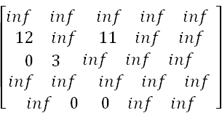
  - Reduce the matrix:
    - Reduced row 2: by 11
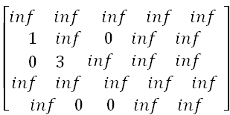

    - Columns are reduced
  - The lower bound is: RCL = 11
  - So the cost of node 8 (Considering vertex 5 from vertex 4) is:
    - Cost(8) = cost(4) + RCL + A(4,5) = 25 + 11 + 0 = 36

- In summary:
  - So the live nodes we have so far are:
    - 2: cost(2) = 35, path: 1->2
    - 3: cost(3) = 53, path: 1->3
    - 5: cost(5) = 31, path: 1->5
    - 6: cost(6) = 28, path: 1->4->2
    - 7: cost(7) = 50, path: 1->4->3
    - 8: cost(8) = 36, path: 1->4->5

  - Explore the node with the lowest cost: Node 6 has a cost of 28
  - Vertices to be explored from node 6: 3 and 5
  - Now we are starting from the cost matrix at node 6 is:

Cost(6) = 28
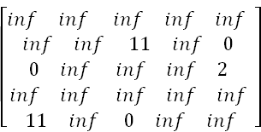

- Choose to go to vertex 3: Node 9 ( path is 1->4->2->3 )
  - Cost of edge <2,3> is: A(2,3) = 11
  - Set row #2 = inf since we are considering edge <2,3>
  - Set column # 3 = inf since we are considering edge <2,3>
  - Set A(3,1) = inf
  - The resulting cost matrix is:

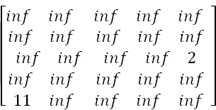

  - Reduce the matrix:
    - Reduce row #3: by 2
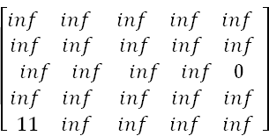

    - Reduce column # 1: by 11
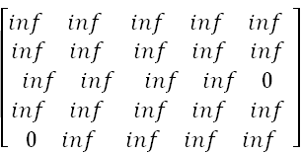

  - The lower bound is: RCL = 2 +11 = 13
  - So the cost of node 9 (Considering vertex 3 from vertex 2) is:
    - Cost(9) = cost(6) + RCL + A(2,3) = 28 + 13 + 11 = 52

- Choose to go to vertex 5: Node 10 ( path is 1->4->2->5 )
  - Cost of edge <2,5> is: A(2,5) = 0
  - Set row #2 = inf since we are considering edge <2,3>
  - Set column # 3 = inf since we are considering edge <2,3>
  - Set A(5,1) = inf
  - The resulting cost matrix is:
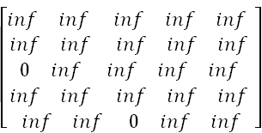

  - Reduce the matrix:
    - Rows reduced
    - Columns reduced
  - The lower bound is: RCL = 0
  - So the cost of node 10 (Considering vertex 5 from vertex 2) is:
    - Cost(10) = cost(6) + RCL + A(2,3) = 28 + 0 + 0 = 28

- In summary:
  - So the live nodes we have so far are:
    - 2: cost(2) = 35, path: 1->2
    - 3: cost(3) = 53, path: 1->3
    - 5: cost(5) = 31, path: 1->5
    - 7: cost(7) = 50, path: 1->4->3
    - 8: cost(8) = 36, path: 1->4->5
    - 9: cost(9) = 52, path: 1->4->2->3
    - 10: cost(2) = 28, path: 1->4->2->5

  - Explore the node with the lowest cost: Node 10 has a cost of 28
  - Vertices to be explored from node 10: 3
  - Now we are starting from the cost matrix at node 10 is:

- Choose to go to vertex 3: Node 11 ( path is 1->4->2->5->3 )
  - Cost of edge <5,3> is: A(5,3) = 0
  - Set row #5 = inf since we are considering edge <5,3>
  - Set column # 3 = inf since we are considering edge <5,3>
  - Set A(3,1) = inf
  - The resulting cost matrix is:
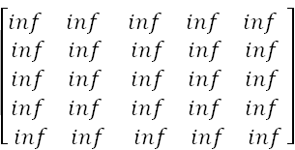

  - Reduce the matrix:
    - Rows reduced
    - Columns reduced
  - The lower bound is: RCL = 0
  - So the cost of node 11 (Considering vertex 5 from vertex 3) is:
    - Cost(11) = cost(10) + RCL + A(5,3) = 28 + 0 + 0 = 28
`

