The George Washington University
School of Engineering and Applied Science
Department of Electrical and Computer Engineering
ECE 20 – SPICE Tutorial 7

Cascading Amplifier Stages (CE to CC)

Background:

In the previous labs you’ve designed common-emitter and common-collector amplifiers. Each amplifier has its own properties for amplifying either the voltage or the current of an incoming signal. Attaching the output of one amplifier to the input of another is known as cascading. Typically this is done to achieve a desired voltage and current gain to deliver certain amount of power to a load. This tutorial will present a problem that requires a cascaded amplifier as its solution.

Problem Statement:

Using a supply voltage of 14 V (DC), build an amplifier that will deliver 1.8mWatts (RMS) to a 400Ω load. The input signal will be 70mV (RMS) at 10kHz. Assume a lab function generator supplies the input signal.

Architecting the Overall System:

- Start by converting everything into “peak” voltages and wattages, instead of RMS values.

Power to deliver to load: 1.8mWatts (RMS) = 2.5mWatts (at the peak)
Input Signal: 70mV (RMS) = 100mV (at the peak)

- You then want to draw a ‘big picture’ of the system you’re about to design:

LOAD
Function generator
100
mV
50Ω
400Ω
We draw the load in a box, because it may not be just a 400ohm resistor, it could be a real device (like the input to another amplifier!). As engineers we just know we need to deliver that device 2.5mWatts of power!

First question to ask yourself, “do I even need an amplifier to reach the goal?” You can perform some basic calculations from the above picture.

Peak voltage across the load: Vload = Vs [ (400) / (400 + 50) ] = 88mV
(this is just voltage division)

So this is good, most of the voltage drops across the Load, since 400 >> 50 (by nearly a factor of 10)

Peak power delivered to load: Pload = V² / R = (88mV)² / 400 = 19μWatts

This answers our question, we cannot just hook the function generator up to the load 19uW(peak) is a far cry from the 2.5mW(peak). Clearly, we need an amplifier of some kind. It should be clear from the power calculation that we require more voltage across the load. The common-emitter amplifier should immediately come to mind, as we know from lab 6 it gives us excellent Voltage Gain.
- The next question to ask is, “how much voltage do I need across my load to achieve the power specification?” You can perform some basic calculations:

Peak power delivered to load: Pload = V² / R → V = √(Pload * R) = √ (2.5mW * 400) = 1V (peak)

We need 1V across our 400ohm load to deliver 2.5mW of peak power to it. A common-emitter amplifier seems like the ideal solution, so let’s redraw our picture:

LOAD
Function generator
100
mV
50Ω
400Ω
Common-Emitter Amplifier
Few kΩ
-Av * vin
> Few kΩ
RIN
ROUT
1V

The best way to think of an amplifier is as if it were a function generator with an input impedance (RIN) and an output impedance (ROUT). And you can set the output voltage by providing “gain” to the incoming input signal.

From lab 6 we realized that the input impedance (RIN) of a common-emitter amp is usually low-to-moderate in the range of a few kΩ. From the picture above, the majority of the 100mV from the function generator will drop across the input of the common-emitter amplifier, since the input impedance of the amp is a few kΩ. That is good!

In lab 6 we realized that the output impedance (Rout) of the common-emitter amplifier is usually high, could be anywhere from a few kΩ to 10kΩ (as it was in lab 6). Let’s assume (for our rough calculations) that it is 10kΩ. Where will most of the output voltage drop? Across the internal 10kΩ resistance of the amplifier!

If the output impedance of the amplifier were 10kΩ, to get 1V across the 400Ω load, we’d need the output voltage to be 26Volts! We’d need to take the ~100mV input voltage and amplify it up to 26Volts, a voltage gain of 260 V/V! While we could design a common-emitter amplifier to do this, 25Volts would be dropped across the internal output resistance of the CE, not only is this a waste, but this would be dissipated as heat eventually melting out amplifier.

So our problem is that, without using an enormous amount of gain, the common-emitter amplifier is unsuitable for ‘driving’ a small load. We really would like to make the output impedance (ROUT) of our common-emitter amplifier MUCH smaller than the 400Ω that we need to ‘drive.’ We want ROUT << RLOAD. One way to do this is to put a common-collector amplifier between the CE amp and the load.

- The next question to ask is, “how can I take the high output impedance of my common-emitter amplifier and make it much, much lower without affecting the voltage gain?” The answer: add a common-collector amplifier.

Let’s redraw our picture:

LOAD
Function generator
100
mV
50Ω
400Ω
Common-Emitter Amplifier
Few kΩ
-Av * vin
> Few kΩ
RIN
ROUT
1V
Common-Collector Amplifier
HIGH kΩ
Av=1
Very low…few Ω’s
ROUT
RIN

We learned in lab 7 that the input impedance of a common-emitter amplifier is typically VERY high. The output impedance is VERY low. And the voltage gain of the amplifier is approximately 1.

Look at the system we now have. The function generator generates 100mV and drops most of it across the common-emitter amplifier’s input. The common-emitter amp ‘amplifies’ the signal and drops most of it across the common-collector amplifier’s input. And finally, the common-collector amp keeps the input voltage the same and drops most it across the load resistor! This is exactly what we wanted, it is as if we’ve taken the very high output impedance of the common-emitter amplifier and ‘transformed’ it to a very low output impedance.

If we design the common-emitter amplifier to have a gain of roughly 10V/V, it will amplify the 100mV input signal to about 1V (peak). 1V peak will be applied to the input of the common-collector amplifier. The common-collector amplifier will not amplify the voltage, it will keep it at roughly 1V. Then most of the 1V signal will be dropped across the 400Ω load.

This is why a common-collector amplifier is typically referred to as a ‘voltage buffer,’ as it “buffers” the input voltage to the output. It can also be thought of as a ‘current amplifier’ because it draws very little current from the common-emitter amplifier, but allows the 400 ohm load to draw the current it needs at the high voltage (1V in this case).

We now have a picture of the system we want to build, now lets move on to how to perform the calculations.

Making the calculations:
Design the Common-Collector Amplifier First:
- Attach the load to a common-collector amplifier & work backwards to determine the necessary bias current (IC):

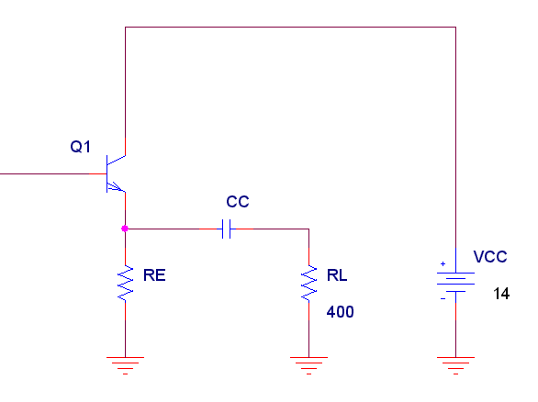
To achieve the peak power goal of 2.5mW, we determined that we need 1V peak across the 400ohm load resistor. The “output voltage” across the 400ohm load must look like fig 1.1.
VC
V(swing)
time
-1V
I(swing)
time
-2.5mA
2.5mA
Fig 1.1 – voltage swing
Fig 1.2 – current swing
1V
VE
IE
From Ohm’s law, we know that if 1V (peak) is applied to a 400ohm load, it will draw 2.5mA of current. The current drawn by the 400 ohm load resistor (over time) will look like the graph in figure 1.2.

We must bias the transistor Q1, so that it will provide enough current to the load (RL) when the current is at either peak: 2.5mA or -2.5mA. We must bias the transistor, so that IE = 2.5mA.
This type of biasing is called Class A and will be discussed further in lecture & lab.

In this tutorial, I’m assuming we’re using the 2N3904 transistor. We must make sure the transistor is capable of delivering 2 * I peak, so in our case 2 * (2.5mA) = 5mA of peak current. We see from the 2N3904 spec (fig 1.3) that is can provide a continuous current of 200mA. Typically a transistor can deliver twice its continuous current at a peak. Our 5mA of peak current is far below 400mA, so we can safely use the 2N3904. For your final project, this may not be the case!
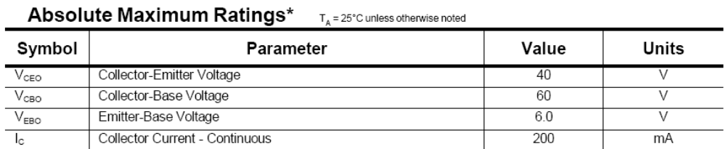
Fig 1.3 – 2N3904 spec.

- Determine RE
From tutorial #6, for a common-collector amp, we learned to set VE = ½ VCC to allow the output voltage swing to be symmetric. This makes VE = 7V. Because IE ≈ IC, we can determine RE using Ohm’s Law:

RE = VE / IE = 7V / 2.5mA = 2.8kΩ

This makes VCE = VC – VE = 14 – 7 = 7V

- Determine the base current (IB):

We use SPICE to plot the IV-cuve (IC vs VCE) for the 2N3904 transistor. We must determine the base-current (IB) necessary to bias the transistor to deliver 2.5mA of emitter current (IE), when VCE = 7Volts. This information helps us determine the Q-point for the 2N3904 transistor is shown in figure 1.4. This is the same technique used in tutorial’s 5 & 6.

Fig 1.4 – IC vs VCE for 2N3904
I(swing)
time
-2.5mA
2.5mA
output current swing
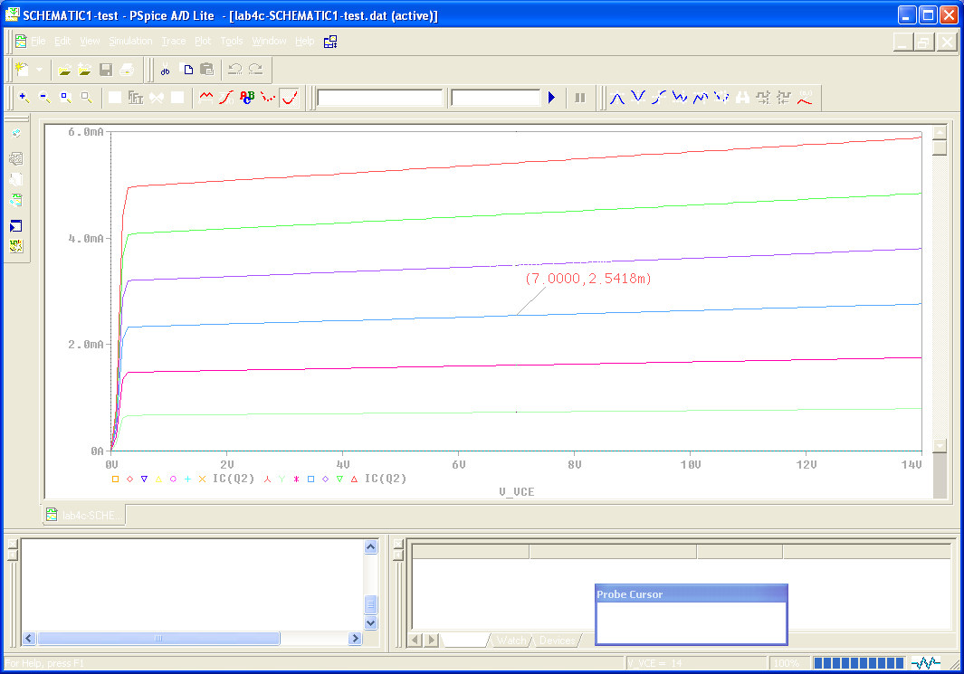
IB = 32uA

IB = 16uA
Q-point

IB = 0uA

output voltage swing
around 7V
1V
-1V

From the graph, we see IB = 16uA to enable
IC ≈ 2.5. From this, we can determine Beta:

β = IC / IB = 2.5mA / 16uA = 156

- Determine RIB:

From tutorial 6, we learned that for a common-collector amplifier, the impedance looking into the base of the transistor: RIB = βre + (β+1) (RE||RL)

where: re = VT / IE, we assume VT = 26mV

Notice that RIB depends on the load attached (this point will be important in your final project).
RIB

We use the formula to calculate RIB = 56kΩ

- Determine RIN, RB, and ROUT:

In labs 6 & 7, you have been given a value for RIN. RIN helps you to determine RB, but now that you are designing the amplifier system, you must determine RIN yourself. When designing a beta-stabilizing network, a safe rule of thumb is to make RB << RIB. How much smaller? A common rule of thumb is to make RB<RIB by a factor of 10. For a common-collector amplifier:

RIN = RB || RIB

If RB = RIB / 10 (divide by factor of 10):

Then RB = 56kΩ / 10 = 5.6kΩ
This makes RIN = 5KΩ

We also know that for a CC amp, Rout ≈ re (little re), which equals = 10.4Ω (very small as expected!)
- Determine R1 and R2:

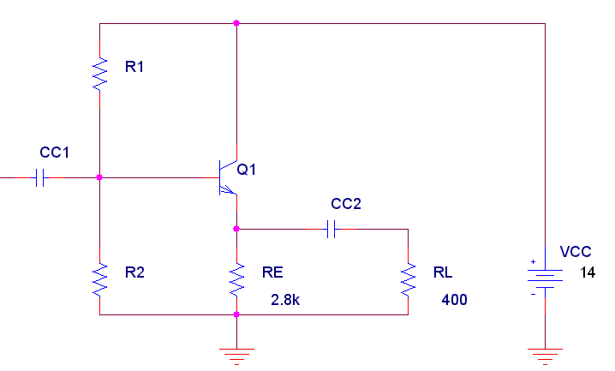
- We can see that R1 & R2 form a voltage divider for VCC.
- Find VB and VBB as you did in tutorials 5 & 6.
- Use VBB, RB, and IB to find R1 and R2 as you did in the previous tutorials
- In this case, VBB = 7.79V, R1 = 11.27k and R2 = 9k

- Simulate the CC amplifier.

Since we’re going to a common-emitter amplifier that will provide a 1V input (as discussed in the system architecture background above), we can simulate just the CC amplifier with an input voltage of 1V at 10kHz:

From the simulation, we can see our biases voltage and currents approximate our calculations
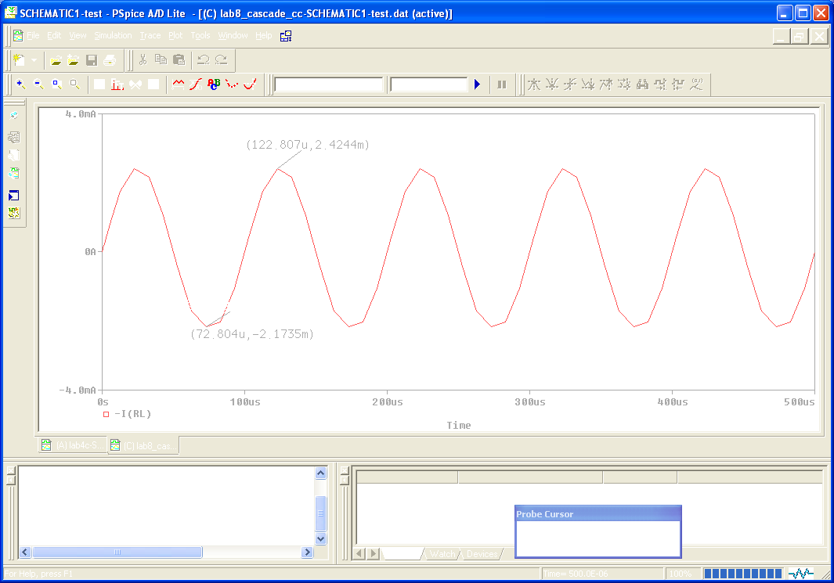
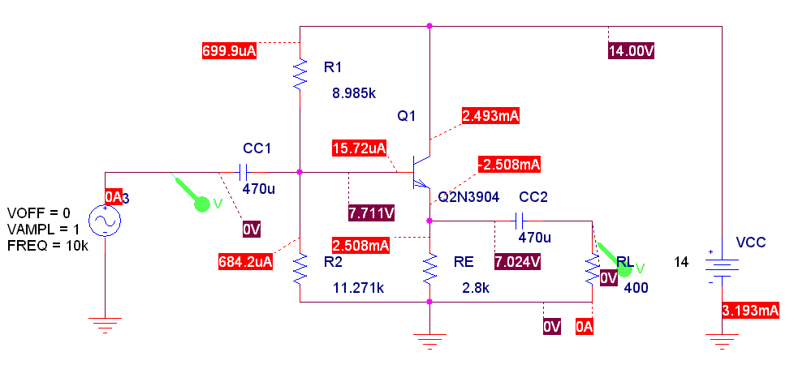

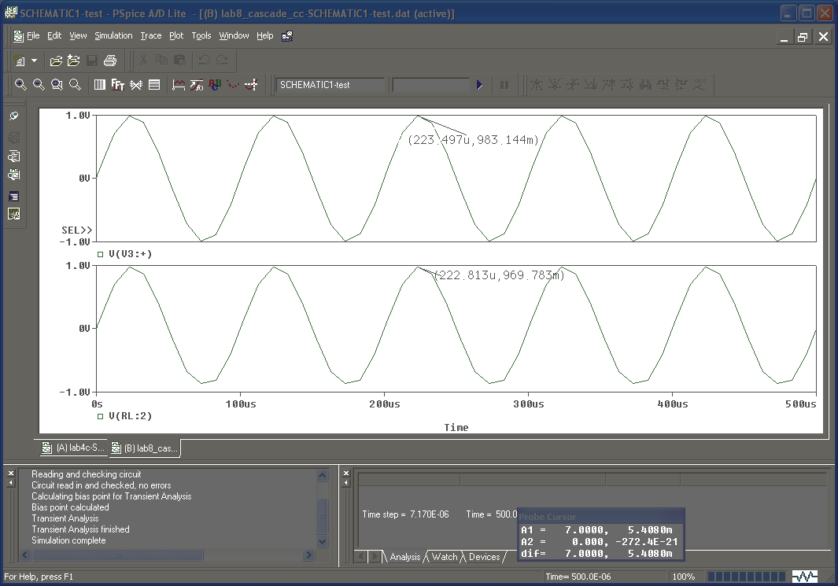
Fig 1.5 – Vout vs Vin (voltage swing) Fig 1.6 – Iout (current swing)

As calculated Vout ≈ Vin ≈ 1V and Iout (through RL) is swinging between -2.5mA to 2.5mA.

Design the Common-Emitter Amplifier Stage

We will be designing a common-emitter amplifier, with a non-bypassed emitter resistor

- Determine the output impedance of the common-emitter amplifier (ROUT)

The input impedance (RIN) of the common-collector amplifier enables us to determine the ROUT of the common-emitter amplifier that we must now design.

LOAD
Function generator
100
mV
50Ω
400Ω
Common-Emitter Amplifier
Few kΩ
-Av * vin
?? Ω
RIN
ROUT
1V
Common-Collector Amplifier
5 kΩ
Av=1
Rout = re= 10.4Ω
ROUT
RIN

In step 5 (from the last section), we calculated the RIN of our amplifier to be 5kΩ. We want the ROUT of our common-emitter amplifier to be smaller than the RIN of our common-collector amp, so that most of the voltage drops across the input of our CC. A good rule of thumb is to make the output impedance of a preceding section to be about 10 times less than the RIN of the following. This will allow about 90% of the voltage to be dropped across the next stage.

If ROUT (of CE amp) = 1/10 RIN (of CC amp), then ROUT = 1/10 (5kΩ) = 500Ω

- Determine the amount of gain required to supply the common-collector amplifier with an input of 1V

In our simulation of the CC amp, we supplied 1V to the input of the CC amp. We need our common-emitter amplifier to supply that 1V to the input of the CC amp. Since the 500Ω output impedance of the common-emitter amplifier will drop about 10% of the voltage, we make our CE amp supply about 1V + 10% or 1.1V. Since our input voltage is ~100mV, we need our common-emitter amplifier to supply a gain of about 11 V/V. Av = -Vout/Vin = -1.1 V / 100mV = -11 V/V

Common-Emitter Amplifier
Few kΩ
-Av * vin
500 Ω
ROUT
Common-Collector Amplifier
5 kΩ
RIN

- Determine RC

Notice in the setup below, we’re attaching an RL of 5kΩ to our common-emitter amp. This RL is to simulate the input impedance (RIN = 5kΩ) of the common-collector amp.

From tutorial 5 we learned that the output impedance of a common-emitter amplifier, is approximately equal to the resistor RC, (ROUT ≈ RC). So we can set RC = ROUT = 500Ω.

- Determine VC and IC

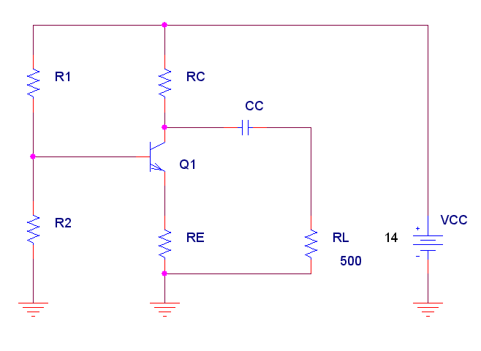
Tutorial 5, we learned to set VC = ½ VCC. Therefore VC = 7V
IC
From Ohm’s law, we know:
IC = (VCC – VC) / RC
VC
= (14V – 7V) / 500 = 14mA

VE

IE

- Determine RE, VE, VB

We determine in step 2 that the gain of our common-emitter amplifier must be -11V/V. We can use this to determine the value of RE for our non-bypassed CE amp.

The gain for a non-bypassed CE amp is: Av = -RC / RE

Rearranging: RE = -RC / Av => RE = -500 / -11 = 45Ω

Since IE ≈ IC, IE = 14mA, we can find VE from Ohm’s law:

VE = IE * RE = 14mA * 45Ω = .63Volts

VB ≈ VE + .7V = 1.33V

VCE = VC – VE = 7V – 1.33V = 5.67V

- Determine IB, Beta, RIB

From the IV-curve of the 2N3904, we can determine that for VCE= 5.67V, if we want IC = 14mA, we need IB = 80uA.

We can calculated Beta = IC/IB = 14mA / 80uA = 175

From tutorial 5, we learned that for a CE amp, base impedance RIB = βre + (β+1) (RE)
(notice this doesn’t depend on the load, like a CC amp does). So RIB = 8.2kΩ

- Calculate RB, RIN, VBB, R1, R2

Using the rule of thumb that RB = 1/10 RIB, one finds RIN = 820Ω

Similar in technique to tutorial 5, VBB = IB * RB + VB = 1.4V

This enables us to find R1 & R2, R1=900Ω, R2 = 8.6kΩ

- Simulate the common-emitter amplifier to verify its operation, for 100mV input, we should see 1.1V out across RL

Cascading the stages together:

- When both the common emitter and common amplifier are complete, cascade them together in spice (remember to “rename” components that have the same name):
Fig 1.7 – Cascaded Common-Emitter / Common Collector
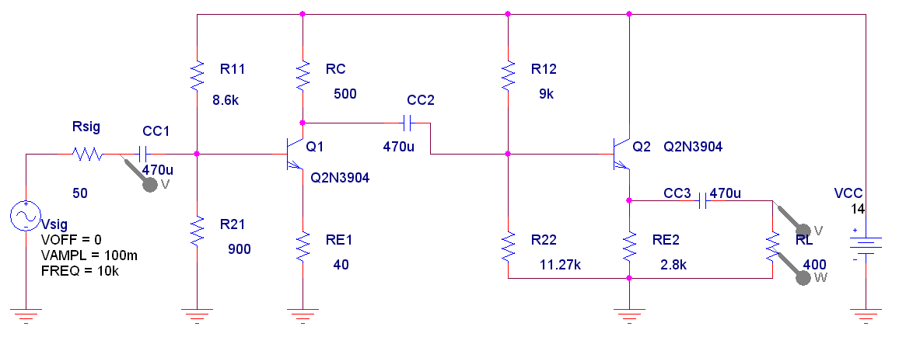
- Simulate the system

In the graphs below, Vin, Vout, and Power out are plotted. Vin is 92mVp (it isn’t 100mV due to Rsig). Vout is .953Vp (it isn’t 1V due to because of Rsig and because a CC amp never has a voltage gain of exactly 1). Power out is nearly 2.5mW at peak, as required by the spec. Notice that it is not 2.5mW at each peak, because there is some voltage clipping by the common-collector amp. Also notice that the gain of the amplifier is negative (due to the common-emitter) and equals -10.3, can you determine why?

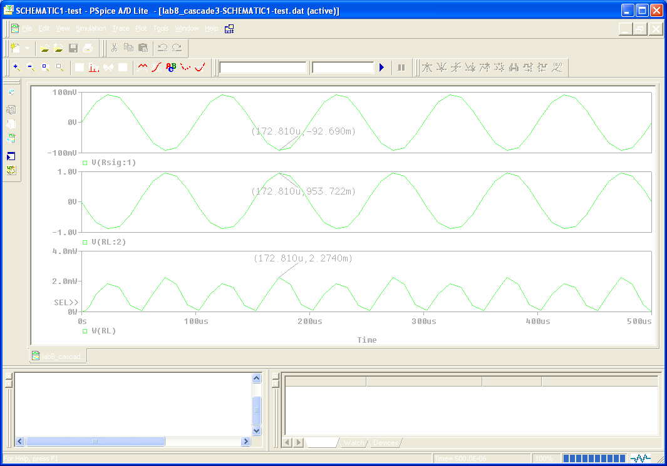
Future Designs:

This amplifier can be built without the use of R11, R21, CC2, R12, and R22. The process of building it is very similar, but by using the RC of the common-emitter as the RB for the common-collector, this amplifier can be made much simpler. As a challenge, can you determine how to do this? We will discuss the design of such an amplifier in lab.

Also, can you tell why this exact design could never work for an 8Ω load? You can easily tell by attempting to use 8Ω as your load for the common-collector amplifier.

